RENAL
CORE CURRICULUM

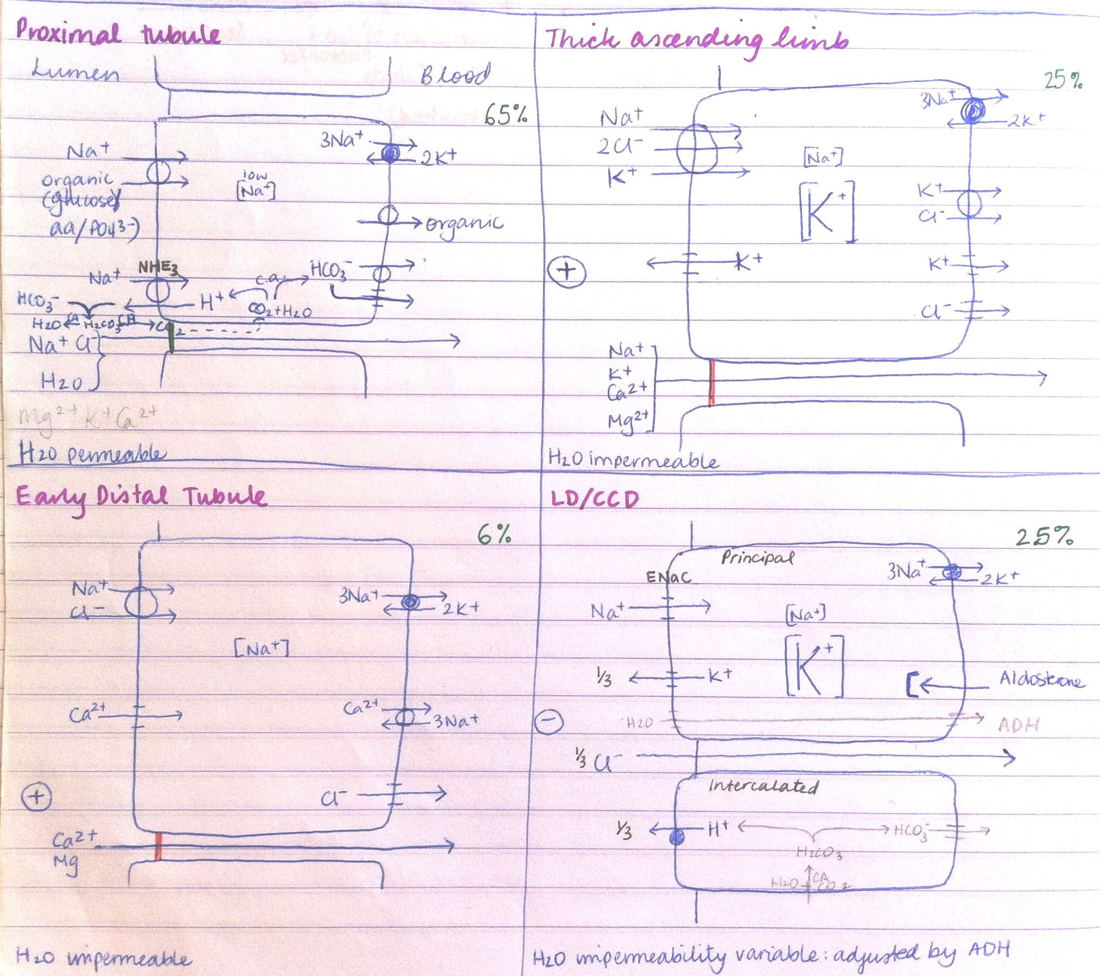

A. BACKGROUND: 1
1. Describe the normal anatomy of the kidneys and lower urinary tract 4
2. Describe the structure and function of the nephron 4
3. Explain the physiological mechanisms by which the kidney regulates: 7
(a) salt and water balance 7
(b) acid – base balance 9
(c) electrolyte balance – potassium, calcium and phosphate 10
(d) blood pressure – including the role of the renin-angiotensin-aldosterone system 11
4. Describe: 12
(a) the effects of hormones produced by the kidney - Vitamin D, erythropoietin, renin 12
(b) the effects of extrarenally produced hormones on the kidney – aldosterone, anti-diuretic hormone 13
(a) renal clearance 13
(b) renal blood flow 14
(c) glomerular filtration rate (GFR) including estimates from creatinine clearance and empirical formulae 14
B. CLINICAL DIAGNOSIS 16
1. Obtain a full renal history with an emphasis on renal risk factors and cardiovascular risk 16
2. Obtain a history from a patient in regard to chronic kidney disease, including the course of their disease, requirements for dialysis and transplantation 16
3. Describe features on history, examination and investigation that suggest that a patient has acute rather than chronic kidney disease 17
4. Obtain a history from a patient to elicit the symptoms of acute upper and lower urinary tract infections 17
5. Perform an examination to assess fluid status 17
6. Measure blood pressure using a sphygmomanometer and interpret the Korotkoff sounds 17
7. Perform an examination on a patient with hypertension, evaluating end organ damage and possible secondary causes of hypertension 17
8. Practice balloting the kidney and recognise techniques that allow an enlarged kidney to be differentiated from the spleen 18
9. Recognise the clinical and biochemical features of metabolic and respiratory acid-base disturbances 18
10. Diagnose metabolic acidosis and initiate investigations for common causes 20
11. Formulate a reasonable provisional and differential diagnosis and initiate appropriate investigation of individual patients presenting with: 23
C. MANAGEMENT OF RENAL EMERGENCIES 40
1. Describe the immediate treatment of a patient with a hypertensive crisis 40
2. Recognise the dangerous consequences and describe the immediate treatment of a patient with acute 41
electrolyte disturbances, in particular hyperkalaemia and hypokalaemia 41
3. Recognise the clinical features of fluid overload and dehydration and discuss management of both presentations 45
4. Recognise the clinical features of an emergency presentation of rapidly progressive glomerulonephritis 45
and explain the role of early aggressive treatment in this clinical scenario 45
5. Discuss the indications for dialysis in acute kidney injury 46
D. IMPORTANT RENAL CONDITIONS 46
1. Acute Kidney Injury (AKI) - previously known as Acute Renal Failure 46
2. Chronic Kidney Disease (CKD) – previously known as Chronic Renal Failure 47
3. End-stage Kidney Disease (ESKD) - previously known as Endstage Renal Failure (a) List the common causes of ESKD in Australia 51
4. Glomerulonephritis 56
5. Inherited Kidney Disease 59
6. Hypertension 60
E. Investigations 66
1. Explain the procedure of renal biopsy to a patient, including the potential risks 66
2. Perform and interpret urinalysis 68
3. Interpret the results of urine microscopy, urine protein/creatinine ratio and 24 hour urine protein quantification 69
4. Interpret the results of a mid stream urine culture 69
5. Discuss the rationale and limitations behind the use of different measures of renal function: 69
2. Discuss the changes seen on renal imaging in obstructive renal disease and chronic kidney disease 70
F. Drugs and therapeutics 71
1. Describe in principle the effects of decreased renal function on drug excretion 71
2. Exhibit a working knowledge of the drugs commonly prescribed in the hospital environment that are renally excreted and how dosage adjustments are made in that situation, with particular reference to digoxin, gentamicin, vancomycin and enoxaparin 71
3. Discuss the general mechanisms whereby drugs can affect kidney function 72
4. Cite common drugs that are likely to induce acute kidney injury 72

A. BACKGROUND:

1. Describe the normal anatomy of the kidneys and lower urinary tract

Essential Genito-Urinary Tract Anatomy
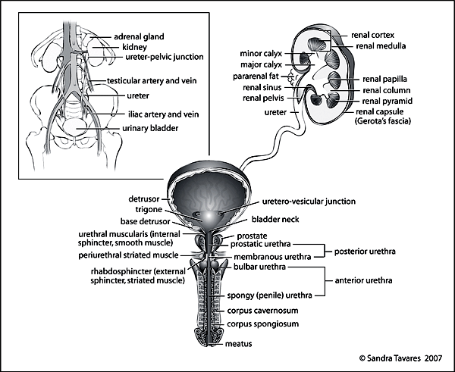

2. Describe the structure and function of the nephron
The Nephron
- basic structural and functional unit of the kidney, approximately 1 million per kidney
- 2 main components: glomerulus (filtration) and attached renal tubule (reabsorption/secretion)
- direction of blood flow: afferent arteriole, glomerular capillaries, efferent arteriole, vasa recta (the capillaries surrounding the tubules), renal venules
- filtration occurs across the glomerular basement membrane into Bowman’s space
- reabsorption and secretion occur between the renal tubules and vasa recta (see figure below)
Nephron components
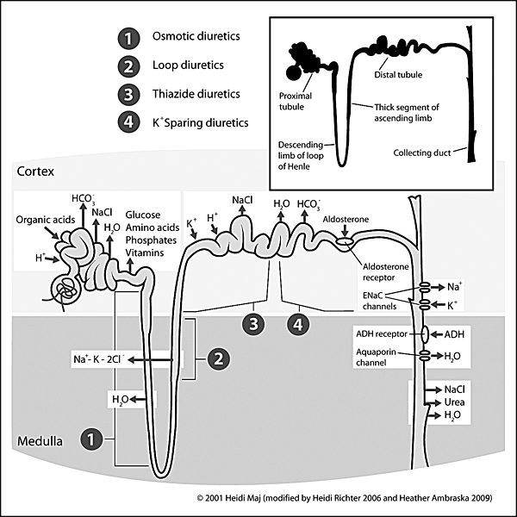
The Glomerulus
- site where blood constituents are filtered through to the kidney tubules for excretion or reabsorption
- Layers of the glomerular filtration barrier:
1. Capillary endothelial cells
2. Glomerular basement membrane
3. Visceral epithelial cells (podocytes)
- particles are selectively filtered by size (<60 kD) and charge (negative charge repelled)
- functions of cell types:
  - capillary endothelial cells and podocytes
    - support the glomerular basement membrane (GBM) and form the plasma filtration apparatus
  - mesangial cells
    - contractile properties and production of vasoactive substances help control the blood flow
  - parietal epithelium
    - covers the interior of Bowman’s capsule
- macula densa is on a section of the distal tubule that passes adjacent to the glomerulus of the same nephron
The Glomerulus
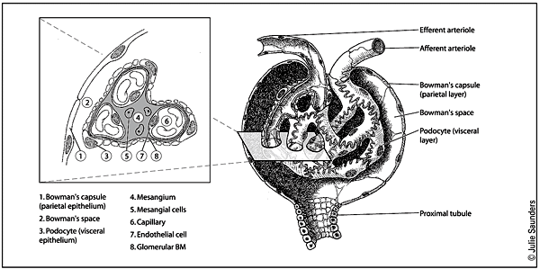
The Renal Tubules
- reabsorption and secretion occur between the renal tubules and vasa recta untll tubular fluid is transformed Into urine for excretion
- each anatomic segment of the nephron has unique characteristics and specialized functions that enable selective transport of solutes and water
- proximal tubule
  - responsible for reabsorbing -60% of filtered NaCl and water, as well as ~90% of filtered bicarbonate and most critical nutrients such as glucose and amino acids
- loop of Henle
  - consists of three major segments by cellular morphology and location: descending thin limb, ascending thin limb and ascending thick limb
  - important role in urinary concentrating ability by contributing to the generation of a hypertonic medullary interstitium
  - contributes to reabsorption of calcium and magnesium ions
- distal convoluted tubule
  - reabsorbs ~5% of the filtered NaCl
  - composed of a tight epithelium with little water permeabillity
  - regulates pH by absorbing bicarbonate and secreting H
  - reabsorbs calcium In response to parathyroid hormone
- collecting duct
  - regulates the final composition of the urine
  - important for hormonal regulation of salt and water balance (water reabsorption governed by antidiuretic hormone)
  - reabsorption of sodium and secretion of potassium at cortical collecting duct regulated by aldosterone
Major Functions of the Kidneys
Function | Mechanism | Affected Elements
Waste Excretion | Glomerular filtration | Nitrogenous products of protein metabolism  (urea, Cr)
 | Tubular secretion | Organic acids (urate)  Organic bases (Cr)
 | Tubular catabolism | Drugs (antibiotics, diuretics)  Peptide hormones  (most pituitary hormones, insulin, glucagon)
Electrolyte Balance | Tubular NaCl absorption | Volume status, osmolar balance
 | Tubular water reabsorption | Osmolar balance
 | Tubular K secretion | Potassium concentration
 | Tubular H secretion | Acid-base balance
 | HCO₃ synthesis and reabsorption | Acid-base balance
 | Tubular Ca, Mg, PO₄ transport | Ca, Mg, PO₄ homeostasis
Hormonal Synthesis | Erythropoietin production (cortex) | Red blood cell mass
 | Vitamin D activation | Calcium homeostasis
 | Renin production (JG apparatus) | Vascular resistance, aldosterone secretion
Blood Pressure Regulation | Altered sodium excretion | ECF volume
 | Renin production | Vascular resistance
Glucose Homeostasis | Gluconeogenesis (from lactate, pyruvate, amino acids) | Glucose supply maintained in prolonged starvation

3. Explain the physiological mechanisms by which the kidney regulates:

(a) salt and water balance

- Over 99% of filtered Na and water is reabsorbed by the tubules
  - 65% in proximal tubule by Na/organic cotransporters (Na with glucose, amino acids, phosphate and others) and Na/H+ exchanger
  - 25% in thick ascending limb of loop of Henle by Na/2Cl/K triple cotransporter
  - 6% in early distal tubule by Na/Cl cotransporter
  - 2.5% in late distal tubule and cortical collecting duct by ENaC sodium channel
- Water movement:
  - Only the proximal tubule is freely permeable to water. Here water follows Na and is reabsorbed.
  - The thick ascending limb is water impermeable and the early distal tubule has low permeability.
  - The cortical collecting duct is made permeable by the action of ADH. Aldosterone acts on the cortical collecting duct to upregulate its Na (and H20) reabsorbing activity.

Mechanisms by which renal sodium transport is regulated
Effector | Stimulated by | Site of action | Net effect
Neurohumoral mechanisms
RAAS | Renin is released from granular cells in juxtaglomerular apparatus in response to low ECF volume sensed by:  - ↓ pressure in afferent arteriole  - NA release from sympathetic nerve endings on granular cells  - ↓ NaCl concentration in distal tubule (due to activated Na reabsorption in earlier segments) | PT: angiotensin II → ↑ Na reabsorption  CCD: aldosterone → ↑ Na reabsorption | Na retention
Sympathetic nervous system / catecholamines | Volume receptors in atria and intrathoracic veins  Baroreceptors in the aortic arch, carotid body and renal afferent arterioles.  Stimulate NA release from sympathetic nerves in kidney. | PT: noradrenaline → ↑ Na reabsorption  Also stimulates renin release  Also vasoconstricts afferent arteriole, reducing GFR | Na retention
Atrial natriuretic peptide | Released from atria when stretched by high volume. | Glomerulus: ↑ GFR  PT: ↓ Na reabsorption  MCD: ↓ Na reabsorption | Na excretion
Natriuretic hormone | Released from brain during high volume states | PT: ↓ Na reabsorption by blocking Na,K-ATPase | Na excretion
Prostaglandins |  | Glomerulus: ↑ GFR  TAL, CCD: ↓ Na reabsorption | Na excretion
Hemodynamic/mechanical mechanisms
GFR changes |  | Glomerulus | ↑ GFR →↑ Na excretion
Hydrostatic and oncotic pressures in peritubular capillaries |  | PT | ↑ filtration fraction causes ↓ Na excretion

- Mechanism of action of aldosterone
  - Acts in cortical collecting duct
  - A steroid hormone, so acts on intracellular receptors
  - Stimulates the production of sodium channels that become inserted in the apical membranes
  - It also stimulates the synthesis of Na⁺, K⁺ ATPase molecules, which are inserted in the basolateral membrane
  - By increasing the number of available channels for sodium uptake, aldosterone promotes sodium reabsorption
  - Increasing the activity of the sodium pump also increases intracellular potassium which can pass into the tubular fluid down its concentration gradient. Therefore more K is excreted as more Na is absorbed
  - As the action of aldosterone requires the synthesis of new proteins, its effect is not immediate but is delayed by an hour or so and it reaches its maximum after about a day
- Mechanism of action of ADH (vasopressin)
  - The osmolality of the extracellular fluid is controlled independently of its volume, volume being determined by total body Na, and osmolality being determined by circulating ADH levels.
  - ADH circulating in the blood binds to receptors on the basolateral surface of the principal (P) cells of the collecting ducts.
  - This initiates the fusion of vesicles containing water channels with the apical membrane. When ADH levels fall, part of the apical membrane is endocytosed and the water channels are taken back into the cells to await recycling.
  - Only some 10–15 per cent of the total filtered load of water is subject to regulation by ADH as the remainder has been reabsorbed along the nephron together with salts and other solutes. If the posterior pituitary is unable to secrete ADH or if the collecting ducts are unable to respond to it, a large volume of dilute urine is produced (polyuria)—in excess of 15 liters of urine can be excreted per day.

(b) acid – base balance
- Normal metabolism results in net production of acid each day:
  - carbon dioxide from oxidative metabolism (volatile acid)
  - acids from the metabolism of dietary protein (mostly sulfuric acid derived from the metabolism of sulfur-containing amino acids) (nonvolatile acid)
    - yet the blood is maintained at an alkaline pH.
- The acid produced is buffered by the carbonic acid/bicarbonate buffer system (CO2 + H2O ↔ H2CO3 ↔ H+ + HCO3-). (The first step is catalysed by carbonic anhydrase, CA). Components of the buffer system are under physiological control: CO2 level is regulated by the respiratory system, and HCO3- level by the kidneys.
- The kidney excretes excess acid resulting in the production of acidic urine.
- HCO3- is freely filtered at the glomerulus, therefore the kidney must reabsorb filtered HCO3- and excrete H+ to achieve this.
- The kidney reabsorbs almost 100% of the filtered HCO3-
  - Mostly in the proximal tubule.
  - Filtered HCO3- combines with H+ secreted by Na+/H+ exchanger to form CO2 and H20 in the tubule. The CO2 is reabsorbed into the proximal tubule cells and combines with water in the presence of CA to produce HCO3- which passes into the plasma, and H+ which provides the H+ for the Na+/H+ exchanger.
  - The net result is HCO3- reabsorption with no net acid secretion
- The kidney secretes H+
  - Via the H+-ATPase in:
    - Intercalated cells of late distal tubule/cortical collecting duct
    - Medullary collecting duct cells
  - The secreted H+ is created intracellularly by carbonic anhydrase. The HCO3- produced is absorbed into the plasma
  - Secretion of H+ results in acidic tubular fluid, with lower pH in more distal parts of the collecting system
  - The secreted H+ is buffered in the tubule by combining with:
    - Filtered HPO4-
    - NH3 manufactured from glutamine in the tubular cells
  - Buffering allows more H+ to be secreted into the urine without the pH falling below 4-4.5
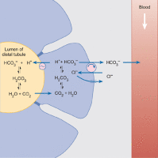
The mechanism by which the intercalated cells of the late distal tubule and cortical collecting ducts secrete hydrogen ions.

(c) electrolyte balance – potassium, calcium and phosphate
potassium
Body potassium balance is regulated by the distal tubules and collecting ducts
- The diet is rich in potassium, with about 4 g (100 mmol) being ingested each day in a normal diet.
- The distal tubule and collecting duct actively regulate potassium excretion.
  - Potassium re-absorption is increased in deficiency and secreted in normal and hyperkalemic states.
  - By the time the filtrate reaches the distal tubule, nearly 90 per cent of the filtered potassium has been reabsorbed.
    - About two-thirds is normally absorbed by the proximal tubule via the para-cellular route
    - 20 per cent is absorbed by the ascending thick limb of the loop of Henle by cotransport with sodium and chloride ions.
    - In the remainder of the nephron, both potassium absorption and potassium secretion can occur and the balance between them determines how much potassium is lost in the urine.
- Potassium secretion into the tubular fluid occurs via a trans-cellular pathway. It is taken up into the P cells by the activity of the Na⁺, K⁺ ATPase located in the basolateral membrane and is secreted into the tubular fluid via potassium channels located in the apical membrane.
- Under normal circumstances the amount of potassium secreted is determined by its concentration in the plasma. If plasma potassium is elevated, this will directly increase potassium uptake into the cells via the Na⁺, K⁺ ATPase.
- Additionally, if plasma potassium is elevated by as little as 0.2 mmol l⁻¹, the secretion of aldosterone by the zona glomerulosa cells of the adrenal cortex is increased. The aldosterone, in turn, stimulates the P cells to synthesize more sodium channels and Na⁺, K⁺ ATPase molecules, which become inserted in the apical membranes and basolateral membranes respectively. These changes augment the uptake of sodium from the tubular fluid and increase the secretion of potassium by the P cells. The effect is to restore plasma potassium to its normal level.

calcium
Calcium ions are absorbed from the distal tubule by an active process that can be stimulated by parathyroid hormone
- About 70 per cent of the filtered load of calcium is reabsorbed in the proximal tubule, 20 per cent is absorbed by the ascending loop of Henle, and most of the remainder is absorbed by the distal tubule and cortical collecting duct.
- Only about 1 per cent is normally excreted.
- Calcium reabsorption occurs by both transcellular and para-cellular routes in the proximal tubule and the ascending limb of the loop of Henle. In the proximal tubule, calcium transport occurs mainly via the paracellular pathway by solvent drag.
- In contrast, in the distal tubule all the calcium uptake is via the transcellular route. This uptake is driven by passive influx of calcium down its steep electrochemical gradient into the tubular cells coupled to active extrusion of calcium across the basolateral membrane.
- PTH stimulates the reabsorption of calcium in the distal tubules and decreases reabsorption of phosphate in the proximal tubules. The net effect of these actions will be an increase in plasma calcium and a fall in plasma phosphate.

phosphate
- Much of the total body phosphate exists as hydroxyapatite, Ca10(PO4)6(OH)2, the main mineral component of bone. Phosphate also is present in high concentration in the cells.
- Plasma phosphorus consists of phospholipids, ester phosphates, and inorganic phosphates. The latter are completely ionized, circulating primarily as HPO42- or H2PO4-.
- The plasma, rather than total body, concentrations of calcium and phosphate are under hormonal control by PTH and vitamin D.
- Actions of PTH on phospate:
- Increases phosphate entry into the extracellular fluid by its effects on bone and intestinal absorption.
- Reduces proximal tubular phosphate reabsorption, resulting in enhanced excretion.
- The urinary effect usually predominates in patients with relatively normal renal function, so PTH tends to lower the plasma phosphate concentration.
- Renal mechanism: PTH diminishes the proximal reabsorption of phosphate by decreasing the activity of the Na+-phosphate cotransporter in the luminal membrane. As a result, luminal phosphate is less able to enter the cells and be returned to the systemic circulation.

(d) blood pressure – including the role of the renin-angiotensin-aldosterone system

BP = CO x TPR. (CO = HR x SV. SV is determined by LV filling volume and force of contraction). Therefore ECF volume and vasoconstriction are significant determinants of BP. Both are regulated by the RAAS.

Stimuli for Renin Release
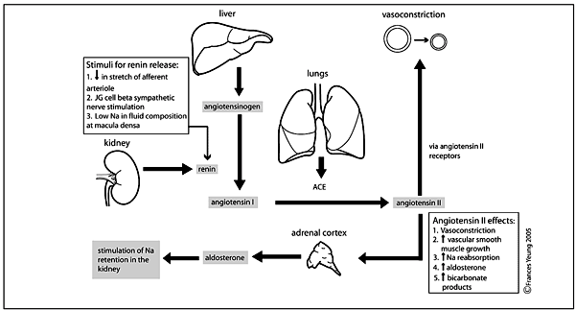

4. Describe:

(a) the effects of hormones produced by the kidney - Vitamin D, erythropoietin, renin

Vitamin D stimulates Ca absorption from GIT
- Plasma calcium and phosphate levels are regulated by 3 hormones:
  - PTH (from parathyroids)
  - calcitriol (from vitamin D/ liver/kidney)
  - calcitonin (from thyroid C cells)
- 2 sources of vitamin D: 1) diet 2) synthesized in skin in presence of sunlight from 7-dehydrocholesterol
- Vitamin D (cholecalciferol) is inactive. It undergoes two hydroxylations (in liver, then in kidney) to become active.
- Actions:
  - Stimulate absorption of calcium (and phosphate) from food
    - Binds to nuclear receptors in intestinal mucosa cells
    - Results in increased synthesis of calcium binding proteins which transport Ca across the cell.
  - Stimulate calcification of bone matrix
    - Direct stimulation of osteoblast and osteoclast activity
  - Action can be summed up as “protecting bones”
Cholesterol→ 7-dehydrocholesterol→(sunlight)→ vitamin D (aka vitamin D3, cholecalciferol) →(liver enzymes)→ 25-OH vitaminD →(kidney enzymes)→ 1,25-OH vitaminD (aka calcitriol)

EPO stimulates RBC production
- Secreted by: peritubular capillary endothelial cells
- Secreted in response to: a fall in tissue PO2
- Action: Accelerates the differentiation of stem cells in the bone marrow to form erythroblasts, so new RBCs are produced at a faster rate.

Renin activates mechanisms to increase ECF volume and raise BP
- Secreted by: juxtaglomerular cells (cells surrounding the afferent arteriole where it enters the glomerulus)
- Secreted in response to: low ECF volume sensed by:
  - ↓ pressure in afferent arteriole
  - NA release from sympathetic nerve endings on granular cells
  - ↓ NaCl concentration in distal tubule (due to activated Na reabsorption in earlier segments)
- Action: Vasoconstrict and increase Na and water reabsorption via angiotensin/aldosterone. Renin is a proteolytic enzyme which converts angiotensinogen to angiotensin I. Angiotensin II is subsequently formed, which a) causes vasoconstriction and b) stimulates aldosterone secretion from adrenal ccortex, which increases salt and water reabsortion in the distal tubule.

(b) the effects of extrarenally produced hormones on the kidney – aldosterone, anti-diuretic hormone
Aldosterone
- Secreted by: Adrenal cortex zona glomerulosa (the outermost layer)
- Secreted in response to: Increased angiotensin II
- Action: Increased Na and water absorption (and K secretion) in distal tubule.
- Mechanism: Stimulates the production of Na channels that are inserted in the apical membranes of distal tubule cells, promoting increased Na reabsorption. This is balanced by increased K secretion, so serum K falls. Onset of action takes 1 hour and peaks after about 1 day.

Anti-diuretic hormone (vasopressin)
- Secreted by: Posterior pituitary
- Secreted in response to: Increased plasma osmolality, sensed by osmoreceptors in hypothalamus. Produced by neurons in the hypothalamus which have their terminals in the posterior pituitary, where they release the ADH. Secretion is inhibited by atrial natriuretic hormone and alcohol.
- Action: Increases permeability of distal tubule and collecting duct. Water is able to flow down its osmotic gradient into the plasma independently of solute uptake, ie. free water is reabsorbed.

5. Outline the principles of measuring:

(a) renal clearance
- Used to estimate the GFR
- Definition: the volume of plasma from which all of a given substance is removed and excreted in urine per unit time.
- Eg. creatinine clearance of 125 mL/min means in 1 minute the kidney can remove all the creatinine from 125 mL of plasma.
- Renal clearance of substances that are completely filtered at the glomerulus (ie. 100% enters the filtrate and none is secreted or reabsorbed) can be used as an estimate of the GFR. Inulin is the gold standard substance (a polysaccharide that can be given by infusion and measured in urine as a formal test of GFR) but is rarely used in practice. DTPA is an alternative used in clinical practice. Creatinine is a close approximation (but there is some secretion of creatinine as well as filtration so creatinine clearance slightly overestimates GFR.
- Clearance is calculated by comparing serum and urinary concentration of a substance (eg creatinine)
- Cx (mL/min) = (Ux x F) x Sx
Where Cx is the clearance, Ux is the urinary concentration of substance, F is the urine flow rate, and Sx is the serum concentration.

(b) renal blood flow
- The normal renal plasma flow is roughly 625 mL/min and renal blood flow is roughly 1100 mL/min or about 25% of the resting cardiac output.
- If systemic arterial pressure is altered over the range of 80–200 mmHg, the renal blood flow remains remarkably constant due to renal autoregulation.
- Paraaminohippurate (PAH) is an easily measured indicator that enters the urine by glomerular filtration and by the organic anion secretory pathway in the proximal tubule. The combination of filtration and secretion results in the almost complete removal of PAH from the plasma in a single pass through the kidney.
- The renal plasma flow can be calculated from plasma and urine concentrations of PAH.
Therefore,
PAH delivery to kidney = PAH excretion
RPF = (UPAH x F) ÷ PPAH
Where RPF is renal plasma flow (mL/min), PPAH is plasma PAH concentration (mg/mL), UPAH is urinary PAH concentration (mg/mL), F = urine flow rate (mL/min).
If the hematocrit (Hct) is known, then the renal blood flow (RBF) can be calculated from,
RBF = RPF ÷ (1 - Hct)
- Since only 85 to 90 percent of the PAH actually is removed from the circulation in a single pass, the PAH clearance will underestimate both RPF and RBF by 10 to 15 percent.

(c) glomerular filtration rate (GFR) including estimates from creatinine clearance and empirical formulae
- GFR = rate of filtration of plasma by the glomeruli
- most renal functions decline in parallel with a decrease in GFR
- GFR is often estimated using serum creatinine concentrations [Cr]
- creatinine (Cr) is a metabolite of creatine (intermediate in muscle energy metabolism)
- rate of production determined by muscle mass
- Cr excreted = Cr filtered (at steady state)
Ways to estimate GFR
Must be in steady state, i.e. constant GFR and rate of production of Cr from muscles
1. Calculate Creatinine Clearance (CrCl)
- calculation provides reasonable estimate of GFR
- requires blood and 24 hour urine samples; measure plasma [Cr], 24 hour urine volume and urine [Cr]
  - GFR = urine [Cr] x urine volume/plasma [Cr] x duration of urine collection in minutes

Serum Creatinine Concentration as a Function of GFR
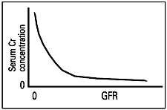
Limitations of use of serum Cr measurements
- 1) must be in steady state
  - sudden injury may reduce GFR substantially, but it takes time for Cr to accumulate and then re-establish steady state
- 2) GFR must fall substantially before plasma [Cr] rises above normal laboratory range (see Figure)
  - with progressive renal failure, remaining nephrons compensate with hyperfiltration
  - GFR is relatively preserved despite significant structural damage
- 3) plasma [Cr] is influenced by the rate of Cr production
  - lower production with smaller muscle mass (i.e. female, elderly, low weight) e.g. consider plasma [Cr] of 100 µmol/L in both of these patients
    - 20 year-old man who weighs 100 kg, GFR = 144 mL/min
    - 80 year-old woman who weighs 50 kg, GFR = 30.6 mL/min
- 4) contribution of tubular secretion to Cr excretion is increased when GFR is low
  - CrCl overestimates GFR
  - certain drugs (cimetidine, trimethoprim) interfere with Cr secretion
- 5) errors in Cr measurement
  - very high bilirubin level causes [Cr] to be falsely low
  - acetoacetate (a ketone body) and certain drugs (cefoxitin) create falsely high [Cr]

2. Cockcroft-Gault formula
- serum Cr used along with age, gender and weight (kg) to estimate GFR
  - multiply the result by 0.85 in women
  - normal range is >90 ml/min (>1.5 ml/s)

Cockcroft-Gault Formula
CrCl (ml/min) = (140-age) x wt (kg) x 1.2 ( x 0.85 in women)
[Cr]plasma (umol/L)
3. MDRD (Modification of Diet in Renal Disease) formula
- most common way in which GFR is estimated
- this is a complex formula requiring information on the following variables:
  - age
  - gender
  - serum Cr
  - African descent
- most helpful way to use this formula is by entering values into online calculators (www.ukidney.com)
- GFR is reported as ml/min/1.73m2 body surface area

B. CLINICAL DIAGNOSIS

1. Obtain a full renal history with an emphasis on renal risk factors and cardiovascular risk
Urinary symptoms
- Change in colour
- Polyuria, nocturia, anuria
- Irritative: Dysuria, frequency, urgency, incontinence, strangury*, overflow incontinence
- *severe pain in the urethra associated with an intense desire to pass urine. It is referred pain from the base of the bladder and occurs when the base of the bladder is irritated by a stone or an indwelling catheter. It is also noted in patients with an invasive cancer of the base of the bladder or severe cystitis or prostatitis, when the strong desire to urinate is accompanied by the painful passage of a few drops of urine.
- Obstructive: Hesitancy, dribbling, decreased stream size, double voiding (incomplete emptying)
- Loin pain, renal colic, history of stones
Chronic renal failure symptoms
- Oliguria, nocturia, polyuria
- Anorexia, metallic taste, vomiting, malaise, fatigue, insomnia, hiccoughs
- Itch, bruising
- Oedema
- Hypertension, hypotension (tubular damage leading to Na loss)
- Anaemia
Chronic renal failure complications:
- Bone pain, fractures (renal osteodystrophy)
- Pericarditis
- Cardiac failure
- Ischaemic heart disease
Sexual history: STIs, discharge, rash, impotence, infertility, loss of libido
Risk factors for renal disease:

- Diabetes
- Hypertension
- Cardiovascular disease
- Hyperlipidemia, obesity, metabolic syndrome
- Smoking
- HIV, Hep C
- Treatment with nephrotoxic drugs
- Gout
- Renal scarring: vesicoureteric reflux – prolonged bedwetting in childhood
- Renovascular disease: vascular disease elsewhere eg. MI, stroke
- Analgesic nephropathy: past use of Bex, Vincent’s powders
- PKD: family history
- Alport’s syndrome: fhx of deafness and renal impairment

2. Obtain a history from a patient in regard to chronic kidney disease, including the course of their disease, requirements for dialysis and transplantation
Dialysis
- Frequency
- Haemodialysis or peritoneal
- What fluid restriction is the patient on
- Phosphate binding drugs
- Amount of weight gain between each dialysis
- Compliance with dietary restrictions.
- Still passing any urine?
- On the transplant list?
- Complications: peritonitis, vascular access problems
Transplant
- Recent renal function tests, how well graft is functioning
- Rejection episodes and their management
- Multiple transplants
- Infections
- Steroid complications: obesity, hypertension, recurrent infections
- Other immunosuppressant complications: cancers, chronic nephrotoxicity (eg. from tacrolimus, cyclosporin), avoidance of sun exposure, regular pap smears

3. Describe features on history, examination and investigation that suggest that a patient has acute rather than chronic kidney disease
Features of chronic: renal osteodystrophy, anaemia (normochromic normocytic), peripheral neuropathy, small kidneys (except in PKD, DM, amyloid, myeloma)

4. Obtain a history from a patient to elicit the symptoms of acute upper and lower urinary tract infections
See dysuria, frequency, urgency in next section

5. Perform an examination to assess fluid status

6. Measure blood pressure using a sphygmomanometer and interpret the Korotkoff sounds
- Inflate cuff to 30 mmHg greater than estimated systolic (by brachial artery palpation).
  - In some patients, the Korotkoff sounds transiently disappear as the cuff is deflated (auscultatory gap). Eg. in pt with systolic of 180 mmHg, sound may be first heard at 180 mmHg, disappear at 165 mmHg, and then be reheard at 140 mmHg, which may lead to inaccurate measurement if not palpated first. The auscultatory gap is associated with increased arterial stiffness and carotid atherosclerosis; it may therefore identify patients at increased risk of cardiovascular disease
- Pt’s arm supported at level of heart. Pt should not talk.
- The stethoscope should be placed lightly over the brachial artery, since the use of excessive pressure can increase turbulence and delay the disappearance of sound.
- The cuff should be deflated slowly at a rate of 2 to 3 mmHg per heartbeat. The systolic pressure is equal to the pressure at which the pulse is first heard by auscultation (Korotkoff phase I) and at which the brachial pulse first returns.
- As the cuff is deflated below the systolic pressure, the pulse continues to be heard until there is abrupt muffling (phase IV) and, approximately 8 to 10 mmHg later, disappearance of sound (phase V). The diastolic pressure is generally equal to phase V, although the point of muffling should be used in those patients in whom there is more than a 10 mmHg difference between phases IV and V. This can occur in children, and in high-output states such as thyrotoxicosis, anemia, and aortic regurgitation.

7. Perform an examination on a patient with hypertension, evaluating end organ damage and possible

secondary causes of hypertension
- Hypertension can be a cause or a consequence of renal disease
Complications/endorgan damage
- Hypertensive retinopathy:
Grade 1 | Silver wiring of arteries only (sclerosis of vessel wall reduces transparency so the central light streak becomes broader and shinier)
Grade 2 | Grade 1 + AV nipping (indentation or deflection of veins where they are crossed by arteries)
Grade 3 | Grade 2 + flame haemorrhages and exudates: soft – cotton wool spots due to ischaemia, hard – lipid residues from leaking vessels.
Grade 4 | Grade 3 + papilloedema
- Left ventricular failure
  - Tachypnoea, exertional dyspnoea, orthopnoea, PND
  - Cool peripheries, peripheral cyanosis
  - Tachycardia, low pulse pressure, displaed apex beat, palpable gallop rhythm
  - Left ventricular S3, functional mitral regurg (secondary to valve ring dilatation)
  - Pulmonary congestion (basal inspiratory crakles) or pulmonary oedema (crackles and wheezes throughout lung fields), central cyanosis
- Fourth heart sound
- Ischaemic heart disease
- Peripheral vascular disease
  - AAA
  - Peripheral perfusion and pulses
- Cerebrovascular disease: neuro signs of previous stroke, carotid bruit (increases likelihood of coexisting renal artery stenosis)
Secondary causes: chronic renal failure, Cushing’s syndrome, acromegaly, polycythaemia, primary aldosteronism, phaeochromocytoma, thyrotoxicosis, hypothyroidism, hypoparathyroidism, coarctation of aorta, oral contraceptive pill
- Renal bruit (renal artery stenosis) (loud, systolic-diastolic, prominent in the epigastrium)

8. Practice balloting the kidney and recognise techniques that allow an enlarged kidney to be differentiated from the spleen
Features of the spleen
- You can’t get above it (but you can feel the top of an enlarged kidney)
- Moves inferomedially with respiration (rather than inferiorly if kidney)
- Has a notch
- Is not balottable (unless gross ascites is present)
- Percussion is dull over the spleen (but usually resonant over kidney, as it lies behind loops of bowel)

9. Recognise the clinical and biochemical features of metabolic and respiratory acid-base disturbances

Disorder | pH | pCO2 | HCO3 | Examples | Clinical features
Respiratory acidosis | ↓ | ↑ | ↑ | Sedative drugs, COPD | Severe CO2 retention: asterixis
Respiratory alkalosis | ↑ | ↓ | ↓ | Panic attack, asthma | Low Ca2+*: peripheral and circumoral paraesthesiae, light-headedness, carpopedal spasm
Metabolic acidosis | ↓ | ↓ | ↓ | Lactic acidosis | Kussmaul breathing: deep respiration (some definitions say with increased rate, others say decreased)
Metabolic alkalosis | ↑ | ↑ | ↑ | Vomiting | ↓ resp rate
*Ca2+ binding to albumin is enhanced in alkalosis, so free plasma Ca2+ drops

Metabolic acidosis – see 10.

METABOLIC ALKALOSIS (more detail - not for core curriculum)
Pathophysiology
- requires initiating event and maintenance factors
- initiating event
  - GI (vomiting, NG) or renal loss of H+
  - exogenous alkali (oral or parenteral administration), milk alkali syndrome
  - diuretics (contraction alkalosis): decreased excretion of HCO₃, decreased ECF volume, therefore increased [ HCO₃]
  - posthypercapnia: renal compensation for respiratory acidosis is HCO₃ retention, rapid correction of respiratory disorder results in transient excess of HCO₃
- maintenance factors
  - volume depletion: increased proximal reabsorption of NaHCO₃ and increased aldosterone
  - hyperaldosteronism (1º or 2º): distal Na reabsorption in exchange for K and H excretion leads to HCO₃ generation, aldosterone also promotes hypokalemia
  - hypokalemia: transcellular K/H exchange, stimulus for ammoniagenesis and HCO₃ generation

Evaluate compensation (identify co-existing respiratory acid-base disorders)
- hypoventilation (an upper limit to compensation exists - breathing cannot be stopped)

Treatment
- treat underlying cause
- correct underlying disease, replenish K and Mg deficits, and possibly K-sparing diuretic
- saline sensitive metabolic alkalosis (most common)
  - treatment: volume repletion
  - ± carbonic anhydrase inhibitor (i.e. acetazolamide) to facilitate loss of HCO₃ in urine
- saline insensitive metabolic alkalosis
  - ECF volume normal or high
  - usually aldosterone or glucocorticoid excess
  - remove source of aldosterone or glucocorticoid ± spironolactone

An Approach to Metabolic Alkalosis
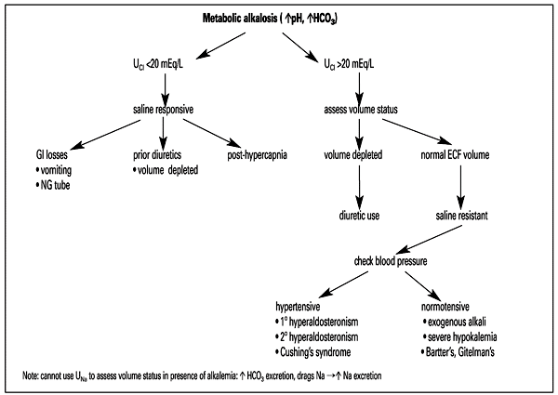

10. Diagnose metabolic acidosis and initiate investigations for common causes
Etiology and Pathophysiology
There are 4 broad aetiologies of metabolic acidosis:
- Increased endogenous acid generation
- Exogenous acid (toxins)
- Loss of bicarbonate
- Diminished renal acid excretion

Metabolic acidosis can also be classified as raised or normal anion gap
Raised anion gap metabolic acidosis (4 types)
1. Lactic acidosis
- L-lactic acid:
  - Type A: situations of tissue hypoperfusion such as shock, septicemia, profound hypoxemia
  - Type B: failure to metabolize normally produced lactic acid in the liver due to severe liver disease, excessive EtOH intake, thiamine deficiency, or metformin accumulation (metformin interferes with electron transport chain)
- D-lactic acid: rare syndrome characterized by episodes of encephalopathy and metabolic acidosis, requires carbohydrate malabsorption (i.e. short bowel syndrome), colonic bacteria that produce D-lactic acid, a carbohydrate load, diminished colonic motility and impaired D-lactate metabolism
2. Ketoacidosis
- diabetic
- starvation
- alcoholic (decreased carbohydrate intake and vomiting)
3. Toxins
- methanol (toxic to retina, can cause blindness) - metabolized to formic acid
- ethylene glycol (toxic to brain and kidneys), metabolized to oxalic acid – (envelope shaped crystals in urine)
- salicylate (aspirin)
4. Advanced renal failure (i.e. serum Cr increased at least 5x above baseline - a very low GFR causes anion retention and renal disease leads to impaired bicarbonate production)

Normal anion gap metabolic acidosis (hyperchloremic acidosis)
- diarrhea (HCO₃ loss from GI tract)
- RTA (renal tubular acidosis)
- type I RTA (distal): inability to fully excrete H load as NH4, therefore H accumulates
- type II RTA (proximal): impaired HCO3 reabsorption
- type IV RTA: defective ammoniagenesis due to decreased aldosterone or hyporesponsiveness or hyperkalemia

- to help distinguish renal causes from non-renal causes, use Urine Anion Gap = (Na + K) - Cl
  - calculation establishes the presence or absence of unmeasured +ve ions (i.e. NH4) in urine
  - if <0, suggests adequate NH4 in urine (likely nonrenal cause: diarrhea)
  - if >0, suggests problem is lack of NH4 in urine (i.e. distal RTA)

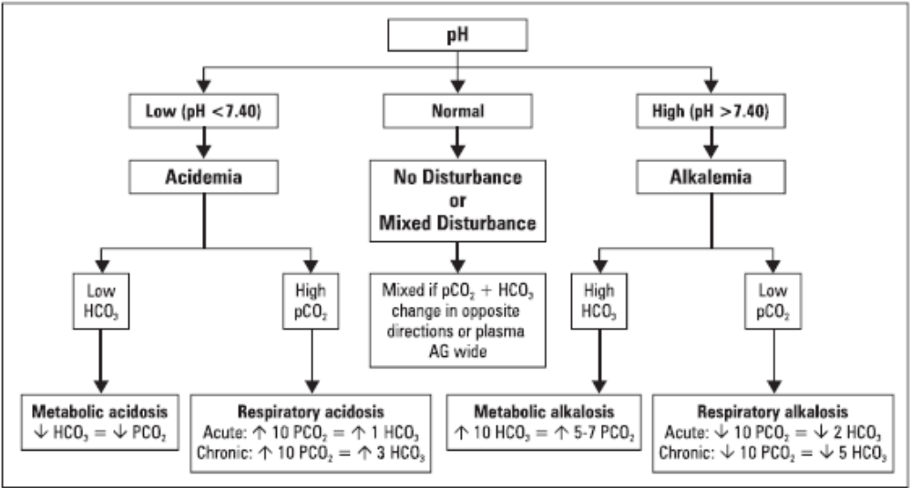

Useful Equations
1) PAG = [Na] - [Cl] - [HCO₃⁻] (normal range = 10-14)
2) Osmolar Gap = measured osmolality - calculated osmolality (normal <10)
3) Calculated Osmolality = 2[Na] + [Urea] + [Glucose]

Approach to metabolic acidosis
- Identify main disturbance as in above figure
- Evaluate compensation (see figure)
  - Inadequate compensation indicates a mixed disorder
- Calculate the plasma anion gap (PAG)
  - PAG can be altered by plasma albumin level: for each 10 g/L fall in albumin, lower baseline PAG by 3
  - If PAG elevated, compare increase in PAG with decrease in HCO₃
    - increase in PAG < decrease in HCO₃, there is a coexisting non-AG metabolic acidosis
    - if increase in PAG > decrease HCO₃, there is a coexisting metabolic alkalosis
- Calculate osmolar gap
  - Calculated osmolality includes the major osmotically active substances normally in blood: cations and the anions that balance them (hence formula is Na multiplied by 2), glucose, urea. Excess unmeasured osmotically active substance causes increased anion gap
  - Toxic alcohols (methanol, ethylene glycol) are metabolised to acids (→ metabolic acidosis) and are osmotically active (→ raised osmolar gap). Therefore, metabolic acidosis + raised osmolar gap = toxic alcohol until proven otherwise.
  - if gap >10, consider: methanol, ethylene glycol (antifreeze), end stage renal disease, alcoholic ketoacidosis, formaldehyde
Causes of Increased Anion Gap Metabolic Acidosis: MUDPILES
Methanol
Uremia
Diabetic/alcoholic/starvation ketoacidosis
Paraldehyde
Isopropyl alcohol/iron
Lactic acidosis
Ethylene glycol
Salicylates
Mnemonic
Causes of Non-Anion Gap Metabolic Acidosis: HARDUP
Hyperalimentation (overfeeding eg TPN)
Acetazolamide
Renal tubular acidosis
Diarrhea
Ureteroenteric fistula
Pancreaticoduodenal fistula

METABOLIC ACIDOSIS
3 Clinical scenarios that produce a mixed metabolic disorder with near normal pH
(i.e. increase PAG metabolic acidosis + resp. alkalosis)
cirrhosis
ASA overdose
sepsis

Treatment of Metabolic Acidosis (not for core curriculum)
- treat underlying cause (insulin for DKA, restore tissue perfusion for Type A lactic acidosis, EtOH + dialysis for methanol overdose, alkaline diuresis + possibly dialysis if level >4 mmol/L for aspirin overdose)
- correct coexisting disorders of K
- consider treatment with exogenous alkali (NaHCO₃) if
  - severe reduction in [HCO₃] e.g. <8 mmol/L, especially with very low pH
  - no metabolizable anion (i.e. salicylate, formate, oxalate, sulphate)
  - note: lactate and ketoacid anions can be metabolized to HCO₃
- risks of sodium bicarbonate therapy
  - hypokalemia: causes K to shift into cells (correct K deficits first)
  - ECF volume overload: Na load given with NaHCO₃, can exacerbate pulmonary edema
  - overshoot alkalosis: abrupt, poorly tolerated transition from overly aggressive alkali loading, partial conversion of accumulated organic anions to HCO₃ and persisting hyperventilation

11. Formulate a reasonable provisional and differential diagnosis and initiate appropriate investigation of individual patients presenting with:
There is no a), b) or c) in the original document. Weird.

(d) microscopic haematuria, (e) macroscopic haematuria
DEFINITIONS
Presence of blood or RBCs in urine
Gross/macroscopic haematuria: urine may be pink, red, or tea-coloured.
Microscopic hematuria: normal coloured urine, >5 RBCs/HPF on microscopy
DDx
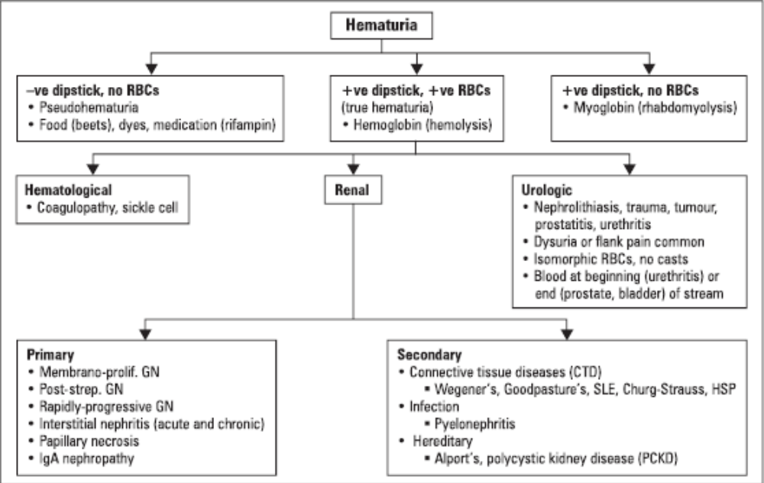
S stones
T trauma
I infection
C cancer
K kidney medical diseases (GN, IgA nephropathy, papillary necrosis, connective tissue diseases)
Ix
Investigations
Note dipstick positive for blood indicates the presence of heme. Microscopy is required to confirm presence of RBCs.
- If gross haematuria, centrifuge the specimen
  - Only the sediment is red = haematuria
  - The liquid is red = haemoglobinuria, myoglobinuria or pseudohaematuria. Do dipstick:
    - Heme positive = haemoglobinuria or myoglobinuria
    - Heme negative = pseudohaematuria (food eg. beetroot, drugs eg. rifampicin)
- Urine MC&S
- Urine urea and creatinine
- 24h urine stone workup: Ca, oxalate, citrate, Mg, uric acid, cysteine
- If casts or proteinuria, then do:
  - FBC, EUC
  - 24h urine protein and Cr
  - serology: ANA, RF, C3, C4, p-ANCA, c-ANCA, ASOT
  - U/S abdo/pelvis
  - Cystoscopy

(f) isolated proteinuria
DEFINITIONS
Daily Excretion | Meaning
<150 mg total protein (and <30 mg albumin) | Normal
30-300 mg albumin | Microalbuminuria
>3500 mg total protein | Nephrotic range proteinuria
Variable amount of proteinuria | Can be seen with glomerular disease; i.e. mild glomerular disease can lead to a mild degree of proteinuria, proliferative lesions may also be associated with some degree of proteinuria
Up to 2000 mg per day | Possible with tubular disease because of failure to reabsorb filtered proteins

- composition of normal total urine protein
  - 60% filtered plasma protein: (50% albumin, 15% Ig, 5% other)
  - 40% Tamm-Horsfall mucoprotein secreted from tubular cells
DDx
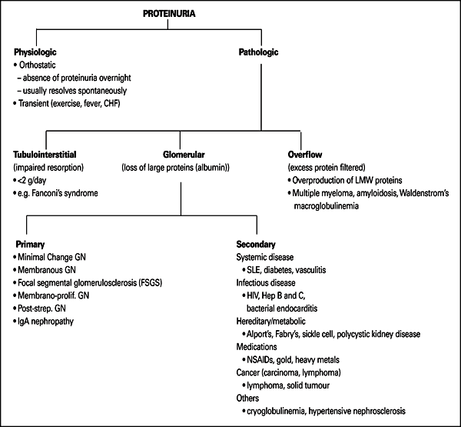
Ix
- Hx and Ex: look for signs and symptoms suggestive of transient physiological or secondary causes (diabetes, CHF, collagen-vascular disease, malignancy)
- Urine MC&S, urea, Cr
- 24 hour urine protein is gold standard to assess degree of proteinuria
- the urine albumin to creatinine ratio (ACR) is used to screen for diabetic nephropathy
  - an elevated ACR (>30 mg/mmol) is the earliest sign of diabetic nephropathy
- further workup (if casts and/or hematuria):
  - FBC, glucose, electrolytes, 24hr urine protein and Cr
  - urine and serum immunoelectrophoresis, abdo/pelvic ultrasound
  - serology: ANA, RF, p-ANCA, c-ANCA, Hep B, Hep C, HIV, ASOT (anti-streptococcal O titre, raised in post-strep GN)

PATHOLOGIC PROTEINURIA
Tubulointerstitial | Glomerular | Overflow
- normally low molecular weight proteins (<60 kD) pass through glomerular filtration barrier and are reabsorbed in proximal tubule  - proximal tubule dysfunction causes impaired resorption and increased excretion of LMWP  - albumin (>60 kD) is NOT affected. Thus, edema is partly secondary to salt and water retention | - normally, the filtration barrier is selectively permeable to SIZE (<60 kD) and CHARGE (repels negative particles). Thus, albumin is NOT filtered through a normal glomerulus  - damage to any component of the glomerular filtration barrier results in loss of albumin and other high MW protein. Thus, edema is secondary to hypoalbuminemia (low oncotic pressure) | - increased production of low molecular weight proteins which exceeds the resorptive capacity of the proximal tubule  - plasma cell dyscrasias: produce light chain Ig (multiple myeloma, Waldenstrom’s, monoclonal gammopathy of undetermined significance)

(g) elevated plasma creatinine
DEFINITIONS
Creatinine is synthesized from amino acids in muscle. It is produced at a relatively constant rate by skeletal muscle, reflects mainly the amount of muscle tissue in the body. It is filtered at the glomerulus and is not reabsorbed by the renal tubules.
Azotemia = high urea and creatinine. Uraemia = high urea and other nitrogenous waste products.
DDx
Classification of Azotemia
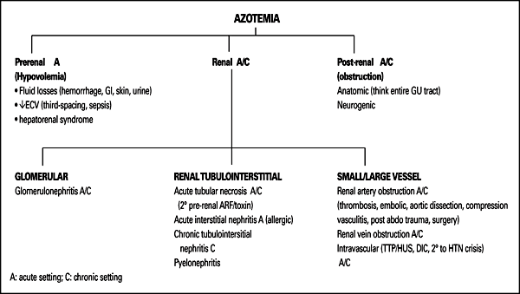
- acetoacetate (a ketone body) and certain drugs (cefoxitin) create falsely high [Cr]
Ix
See AKI and CRF

(h) nephrotic syndrome
- Note there is significant overlap in the causes of nephritic and nephrotic syndromes.
- Patients with glomerular disease may present with:
  - Nephritic syndrome
  - Nephrotic syndrome
  - Rapidly progressive GN
  - Asymptomatic proteinuria and/or microscopic haematuria
  - Macroscopic haematuria
  - Acute kidney injury
  - Chronic renal failure
  - Hypertension
- each glomerulonephropathy can be due to a primary disease OR can occur secondary to a systemic disease
- some glomerulonephropathies can present as more than one syndrome at different times
The Spectrum of Glomerular Pathology:
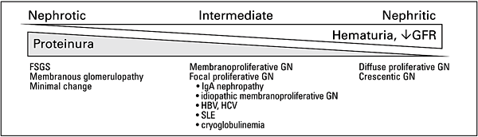

DEFINITIONS
Presentation of Nephrotic Syndrome
1) severe proteinuria (>3.5 g/d)
2) hypoalbuminemia
3) edema
4) hyperlipidemia, lipiduria
5) oval fat bodies, fatty casts (microscopy)
6) hypercoagulable state (protein C and protein S lost in urine)

DDx
Patients with the nephrotic syndrome may have either primary renal disease (minimal change disease, membranous nephropathy, or focal segmental glomerulosclerosis) or a systemic disorder that affects the kidneys (lupus, postinfectious glomerulonephritis, amyloidosis, hepatitis B or C virus infection, HIV infection, mixed cryoglobulinemia, or syphilis).
Renal diseases presenting as nephrotic syndrome
 | Minimal Change | Membranous Glomerulopathy | Focal Segmental Glomerulosclerosis | Membranoproliferative Glomerulonephritis
Secondary causes | DM, amyloidosis | HBV, SLE, malignancy (lung, breast, GI) | Reflux nephropathy, HIV, HBV, obesity | HCV, malaria, SLE, leukemia, lymphoma, infected shunt
Drug causes | NSAIDs | Gold, penicillamine | Heroin | N/A
Therapy | Steroids | Reduce BP, ACEI, steroids | Steroids, ACEI/ARB for proteinuria | Aspirin, ACEI, dipyridamole (Persantineâ„¢) - controversial

Ix
- Assess degree of proteinuria
  - 24 hour urine collection. Normal is <150 mg/day. >3 g/day is nephrotic-range proteinuria (some sources say 3.5).
  - Calculating total protein:creatinine ration (mg/mg) on a random urine specimen is an alternative to 24-hour collection
When heavy proteinuria has been diagnosed, the cause may be evident from history and examination if the patient has a systemic disease or uses a drug from the table above. Most patients, however, will require a renal biopsy. Serology can help identify secondary causes and in some cases avoid the need for a biopsy.
- Serology: see nephritic syndrome for the list of tests
- Renal biopsy: see nephritic syndrome for results interpretation

(i) nephritic syndrome
DEFINITIONS
The nephritic syndrome comprises haematuria and proteinuria, often with HTN, pulmonary and peripheral oedema, oliguria and rising urea and Cr
Features of Nephritic Syndrome
P – Proteinuria (usually only 1-2+ on dipstick ie. mild)
H – Hematuria (micro or macro)
A – Azotemia (increased Cr and urea)
R - RBC casts and/or dysmorphic RBCs in urine
O – Oliguria, oedema
H – Hypertension (due to salt and water retention)
Aetiology
- Aetiology can be divided into low and normal complement levels (table below)
- frequently immune-mediated, with Ig and C3 deposits found in GBM
- outcome dependent on etiology
DDx
- Differential is wide and includes most of the diseases capable of producing glomerulonephritis
- IgA nephropathy (Berger’s disease) is the commonest GN in the developed world.

Etiology of Nephritic Syndrome
 | Low Complement Level | Normal Complement Level
Primary Causes | Postinfectious GN  Membranoprolif. GN | IgA nephropathy  Anti-GBM disease
Secondary Causes | SLE  Endocarditis  Abscess or shunt nephritis  Cryoglobulinemia | Polyarteritis nodosa  Wegener’s granulomatosis  Henoch-Schonlein purpura  Goodpasture’s syndrome

Rapidly progressive (crescentic) GN, in which renal failure develops over a period of days to weeks, can occur in several conditions, including primary crescentic GN, microscopic polyangitis and Goodpasture’s syndrome, therefore recognising and treating these early is essential.
Ix
1. 24h urine: protein
2. Urine microscopy
- A centrifuged specimen is used to examine the sediment looking for leukocytes, red cells, casts and crystals.
- Types of cast:
  - Granular: suggests glomerular or tubular disease eg. GN, interstitial nephritis
  - Hyaline: proteinaeous, found with proteinuria. Can also be in normal concentrated urine.
  - Red cell casts: prove that haematuria is glomerular, rather than coming from another part of the urinary tract. Suggests vasculitis, glomerulonephritis, or malignant hypertension
  - Fatty: occur in moderate-heavy proteinuria
  - FYI: casts in other conditions: white cell casts occur in pyelonephritis, tubular cell casts in acute tubular necrosis
- ‘Active’ sediment: elements consistent with renal inflammation and/or cell necrosis
- ‘Benign’ sediment: few cells, only hyaline casts.
- Urine should be examined immediately as casts may break down in 1-2 h
3. Serological tests in GN
Test | Diagnosis
Low C3 (due to complement activation) | Low in post-strep GN, mesangiocapillary GN
Low C3, C4 | Low in SLE
ANA, anti-DS DNA | SLE
ANCA | Microscopic polyangitis, Wegener’s granulomatosis
Anti-GBM antibody | Goodpasture’s syndrome
ASOT (antistreptococcal O titre) | Post-strep GN
HbsAg | Hep B
Anti-HCV | Hep C
HIV | HIV/AIDS
VDRL | Syphilis
Cryoglobulin | high titres in a patient with nonthrombocytopenic purpura and systemic symptoms sugggests mixed cryoglobulinemia.
- Serum or urine electrophoresis - the presence of a monoclonal protein suggests primary amyloidosis or light chain deposition disease in which the tissue deposits are composed of fragments of monoclonal light chains. In this setting, the diagnosis can often be established by a less invasive rectal, abdominal fat pad, or gingival biopsy, rather than renal biopsy.
4. Renal biopsy
- Microscopy shows the pattern of cellular infiltrate/proliferation and scarring
  - Crescents are cellular, fibrinous lesions (or fibrous in later disease) in Bowman’s space. They are seen in many forms of GN. Greater size and number of crescents indicates disease severity.
  - Large and numerous crescents (in >50% of glomeruli) are associated with a rapidly progressive course in primary crescentic GN and some forms of vasculitis (microscopic polyangitis, Wegener’s granulomatosis, Goodpasture’s syndrome). It is important to identify and treat these early.
- Immunofluorescence shows the location of immune complexes in the glomerulus:
  - Complexes can be on mesangial cells (mesangial distribution, as in IgA disease) or the glomerular capillary wall.
  - Glomerular capillary wall deposits can show 2 patterns:
    - A discontinuous or granular pattern occurs when circulating immune complexes are deposited in the glomerulus or immune complexes form in situ
    - A continuous, linear pattern occurs when an antibody is directed against an intrinsic renal antigen (Goodpasture’s syndrome)
- Electron microscopy shows podocyte foot process fusion, GBM thickening or deposits in various parts of the glomerulus depending on the type of GN

(j) acute kidney injury
DEFINITIONS
- Formerly called acute renal failure.
- Abrupt loss of kidney function that results in the retention of urea and other nitrogenous waste products and in the dysregulation of extracellular volume and electrolytes.
- There may be no symptoms or signs, but oliguria is common.
- The loss of kidney function is most easily detected by measurement of the serum creatinine which is used to estimate the glomerular filtration rate (GFR).
- May be an isolated problem but more commonly occurs in the setting of circulatory disturbance (eg. severe illness, sepsis, trauma, surgery) or related to nephrotoxic drugs.
DDx
Prerenal (renal hypoperfusion)
- Shock
  - Hypovolaemia (bleeding, GI loss, skin loss, renal loss)
  - Cardiogenic
  - Distributive (sepsis, ascites, pancreatitis)
- Renal artery stenosis, thrombosis
- Small vessel haemodynamics
  - NSAID
  - ACEI
Renal
- Vessels: vasculitis, malignant hypertension, cholesterol emboli, haemolytic uraemic syndrome, thrombotic thrombocytopenic purpura, hepatorenal syndrome
- Glomeruli: Rapidly progressive GN
- Actute interstitial nephritis: mediated by delayed type hypersensitivity reaction to many common medications and infectious agents. Fever, rash, eosinophilia, raised IgE.
- Acute tubular necrosis:
  - Ischaemic (prolonged pre-renal insult)
  - Toxic (prolonged toxic insult)
    - Drugs: Aminoglycosides, tetracyclines
    - Radiocontrast
    - Mb in rhabdomyolysis
    - Myeloma
- Intratubular obstruction by crystals – uric acid (tumor lysis syndrome), oxalate, acyclovir
Postrenal obstruction
- Ureter: stones, papillae, blood clots, neoplasm, external eg retroperitoneal fibrosis, neoplasm
- Bladder: BPH, neoplasm, rupture, neurogenic bladder, anticholinergics, alpha agonists
- Urethra: stricture, neoplasm, clot
Ix
- Consider the renal effects of all drugs the patient is on
- Is there obstruction?
  - Suspect in patients with a single functioning kidney or those with history of stones, anuria, prostatism or previous pelvic/retroperitoneal surgery
  - Examine for palpable bladder, pelvic/abdo masses, enlarged prostate. Catheterise to rule out.
- Urine
  - Dipstick
  - Microscopy: RBC, WBC, crystals, casts
  - Culture and sensitivity
  - Chemistry: U&E, Cr, osmolality, Bence-Jones protein (a low molecular weight protein found in the urine in multiple myeloma)
- Blood
  - FBC, EUC (beware hyperkalaemia), CMP, clotting, CK-MB (rhabdomyolysis)
  - Consider ABG, blood cultures (sepsis)
  - If cause is unclear consider doing all the investigations for GN: serum immunoglobulins, electrophoresis, c3, c4, autoantibodies (ANA, ANCA, anti-dsDNA, anti-GBM, ASOT)
- Fluid challenge
  - Give 250-500 mL crystalloid or colloid over 30 min to rule out prerenal causes.
- CXR
  - Pulmonary oedema?
- ECG
  - Hyperkalaemia?
- Indications for renal biopsy:
  - diagnosis is not certain
  - prerenal azotemia or ATN is unlikely
  - oliguria persists >4 weeks

(k) chronic kidney disease
DEFINITIONS
Abnormal GFR for >3 months
aka chronic renal failure
Stages of Chronic Kidney Disease
 | Definition | GFR (mL/min/1.73m²)
Stage 1 | Normal or increased GFR (in context of renal disease) | >90
Stage 2 | Mild decrease in GFR | 60-89
Stage 3 | Moderate decrease in GFR | 30-59
Stage 4 | Severe decrease in GFR | 15-29
Stage 5 | End stage renal disease | <15 (or dialysis)

DDx
Etiology and Incidence of Chronic Kidney Disease (CKD)
Diabetes | 42.9%
Hypertension | 26.4%
Glomerulonephritis | 9.9%
Other/Unknown | 7.7%
Interstitial nephritis/Pyelonephritis | 4.0%
Cystic/Hereditary/Congenital | 3.1%
Secondary GN/Vasculitis | 2.4%
Others: BPH, analgesic nephropathy, renal stones, myeloma, amyloidosis, SLE, scleroderma, gout, renal tumor.
History
- Causes: past UTIs, hypertension, DM, family history
- Drug history
- Symptoms: fatigue, wakness, anorexia, vomiting, metallic taste, pruritus, restless legs, bone pain, impotence/infertility, fluid overload (dyspnoea, ankle swelling), urine output.
Examination
- Pallor, yellow skin, brown nails, purpura, bruising, excoriation, hypertension, cardiomegaly, pericardial rub, pleural effusion, pulmonary or peripheral oedema, proximal myopathy
- Late signs: arrhythmias, encephalopathy, seizures, coma
- Cause: eg DM (peripheral neuropathy, retinopathy)
Ix
Blood (effects of renal failure: anaemia, uraemia, calcium/phosphate dysregulation)
- Normochromic, normocytic anaemia
- ESR
- EUC (raised urea and creatinine)
- ↓ Ca2+, ↑ phosphate
- ↑ alkaline phosphatase (renal osteodystrophy)
- ↑ PTH
- BSL (DM)
Urine
- Dipstick
- MC&S
- 24 h urine protein
Imaging
- Renal ultrasound: exclude obstruction, look at size (usually small ie <9 cm, but may be normal or large in DM, PKD, amyloidosis, myeloma, systemic sclerosis, asymmetric renal vascular disease.
- Consider DTPA scan
- CXR: cardiomegaly, pleural/pericardial effusion, pulmonary oedema
- Bone xrays: may show renal osteodystrophy
Renal biopsy
- Consider if the cause is unclear and there are normal sized kidneys.

(l) end stage kidney disease
see above

(m) loin pain

DEFINITIONS
Loin is the area of the back and side between the lowest rib and the pelvis
Upper ureter or renal pelvic obstruction leads to flank pain or tenderness. Lower ureteral obstruction causes pain that may radiate to the ipsilateral testicle or labium.
DDx
Renal colic-like pain
- Nephrolithiasis
- Clot in ureter (clot colic) due to renal cell carcinoma (NB glomerular bleeding does not lead to clots)
- Ectopic pregnancy
- AAA
- Acute intestinal obstruction or appendicitis
- Drug seeking
Ix
- Non-contrast CT is the investigation of choice when nephrolithiasis is suspected.
  - Detects both stones and urinary tract obstruction
  - Can detect stones that are not seen on KUB or intravenous pyelogram, as slices are 3-5mm in thickness
  - If the patient turns out to not have stones, other serious causes of pain can be identified
  - Note that ureteric dilatation in the absence of a stone may be due to recent stone passage

(n) dysuria, frequency, urgency

DDx
- Acute pyelonephritis
  - Dysuria, frequency, urgency + fever, rigors, malaise, flank pain
  - RFs: calculi, reflux, obstruction, neurogenic bladder
  - In an obstructed kidney requires immediate attention as irreversible loss of renal function may occur
- Acute cystitis
  - UTI confined to the urinary tract, not involving kidneys
  - Dysuria, frequency, urgency + suprapubic discomfort, incontinence, microscopic haematuria
  - More common in women
  - Coliforms are the most common infecting organisms:
    - E. coli (90% outpatients, 50% inpatients)
    - Proteus, klebsiella (5% outpatients, 20% inpatients)
    - Enterococci (2% outpatients, 7% inpatients)
    - Pseudomonas (0.5% outpatients, 6% inpatients)
- Urethritis (males)
  - Dysuria and meatal discharge
  - Most commonly caused by STIs eg. gonococcus, chlamydia.
- Other causes of dysuria
  - Bladder calculi
  - Bladder tumours
  - TB (suggested by sterile pyuria in a patient at risk of TB)
- Recurrent infection: obstruction, prostatitis, renal calculi, DM and bladder dysfunction are potential causes, abnormal urinary tract eg. reflux
Ix
- Dipstick
  - Nitrite + reflects the presence of enterobacteriaceae, which convert urinary nitrate to nitrite. Dipstick is fairly sensitive and specific for detecting ≥10⁵ CFU/mL of enterobacteriaceae but is not sensitive for other organisms.
  - Leukocyte + may be used to detect >10 leukocytes per high power. Sensitivity varies.
- Urine MC&S
  - Specimen should be midstream
  - The definition of a positive culture is bacteriuria ≥10⁵ CFU/mL and pyuria ≥10³ WBC/mL
  - There are some situations where a lower bacterial count can represent true infection rather than contamination:
    - Pts already on antibiotics
    - Men (contamination much less likely than in women)
    - Organisms other than E. coli and proteus
    - In symptomatic women with pyuria a lower bacteria level (≥10⁵ CFU/mL) has been associated with positive suprapubic aspirate culture and response to antibiotics, therefore the definition may not always be appropriate
  - Bacteriuria alone is likely to reflect contamination
  - Pyuria alone (sterile pyuria) can be due to true infection: pt already taking antimicrobials, contamination of the urine by sterilizing solution, atypical organism such as chlamydia, ureaplasma urealyticum or TB, or no infection: contamination with vaginal leukocytes, chronic interstitial nephritis, nephrolithiasis, uroepithelial tumor.
  - Normal values for MSU are bacteria <10⁵ CFU/mL and WBC <10³ WBC/mL
- Other investigations especially in recurrent infection
  - BSL
  - Renal tract US
  - Xray of kidneys, ureters, bladder
  - Cystoscopy

(o) polyuria, oliguria, anuria
polyuria
DEFINITIONS
Excessive urine volume, usually >3L/day
Diabetes mellitus is the most common cause
DDx
- Primary polydipsia: excessive fluid intake due to psychological disturbance
- Increased tubular solute load, as with urea in chronic renal failure or glucose in DM
- Disordered medullary concentration gradient: medullary disease, hypercalcaemia
- ↓ ADH production (central diabetes insipidus): head trauma, tumours or infections of hypothalamus or pituitary
- ↓ tubular response to ADH (nephrogenic diabetes insipidus): hypercalcaemia, chronic K depletion, lithium toxicity, congenital mutation in ADH receptor V2 or aquaporin-2 water channel.
- After relief of urinary tract obstruction
Ix
- History may provide the diagnosis
- BSL
- Cr, Ca, K
- Water deprivation test if diabetes insipidus suspected is used to diagnose DI and distinguish it from primary polydipsia: Patient is instructed to not drink and urine and serum osmolality are measured hourly. In polydipsia, the osmolality will become normal, indicating intact ADH release and effect. In DI, the urine osmolality will be stable despite rising plasma osmolality. When exogenous ADH (desmopressin) is given there will be no response in polydipsia, as endogenous ADH is already having maximal effect, but urine osmolality will rise in central diabetes insipidus.

Oliguria, anuria
DEFINITIONS
Oliguria is urine output ≤0.5 mL/kg/h
DDx
Hospitalised patient
- Catheterised patient: blocked or kinked catheter is the most common cause of decreased urine output! Flush the catheter.
- Pain and nausea are potent stimuli of ADH secretion- important in postsurgical patients
- Differential diagnosis is prerenal/renal/postrenal as for AKI
Ix
- Assess fluid balance – the patient may be underfilled (bleeding, diarrhea, inadequate maintenance fluid), or overloaded.
- Investigate as for AKI

(p) oedema

DEFINITIONS
Volume overload due to renal impairment can manifest as either secondary hypertension and/or generalized oedema
DDx
Increased hydrostatic pressure
- Increased fluid retention
  - Cardiac causes e.g. CHF
  - Hepatic causes e.g. cirrhosis
  - Renal causes e.g. acute and chronic renal failure
- Vasodilators (especially calcium channel blockers)
- Refeeding edema
Decreased oncotic pressure
- Hypoalbuminemia
Hormonal
- hypothyroidism
- exogenous steroids
- pregnancy
- estrogens
Ix
- If renal cause suspected, investigate as for nephritic and nephrotic syndromes

(q) electrolyte abnormalities (hyponatraemia, hypernatraemia, hypokalaemia, hyperkalaemia)

Sodium homeostasis
- hyponatremia and hypernatremia are disorders of water balance
  - hyponatremia suggests too much water in the extracellular fluid relative to Na
  - hypernatremia is too little water in the extracellular fluid relative to Na
  - both can be associated with normal, decreased or increased total body Na
- solutes (such as Na, glucose, or urea) that cannot freely traverse the plasma membrane contribute to effective osmolality and induce transcellular shifts of water
  - water moves out of cells in response to increased ECF osmolality
  - water moves into cells in response to decreased ECF osmolality
- physiologically, ECF volume is determined by Na content, not Na concentration
  - Na deficiency leads to ECF volume contraction
  - Na excess leads to ECF volume expansion
- clinical signs and symptoms of hyponatremia and hypernatremia are secondary to cells (especially in the brain) shrinking (hypematremia) or swelling (hyponatremia)

hyponatraemia
DEFINITIONS
- Too much water in the ECF relative to Na (can be in the context of normal, decreased (most common) or increased total body Na)
- a decrease in serum [Na] to <136 mmol/L
DDx
Mechanisms of Hyponatremia
1. Hyponatremia despite dilute urine (U_{osm}<100)
- expect urine to be dilute with hyponatremia (ADH should be suppressed)
- due to excessive water intake that overwhelms the kidneys’ normal water excretion capacity
  - psychogenic polydipsia in psychiatric patients (e.g. schizophrenia)
- ability to excrete water is compromised in people with low solute excretion (particularly urea)
  - e.g. elderly women with â€œtea and toastâ€ diet: low protein intake, low urea excretion

2. Hyponatremia with concentrated urine (U_{osm}>200)
- if urine remains concentrated, ADH is acting when it should not be
- may be physiological (due to volume stimulus) or pathological (other reasons)
  - volume mediated ADH release can be due to true or effective volume depletion
  - causes of true volume depletion include losses from skin, GI, urine, blood or 3rd spacing
  - â€œeffectiveâ€ volume loss is seen with CHF and cirrhosis
  - pathological ADH release: SIADH and endocrine deficiency
  - adrenal insufficiency (decreased volume and co-secretion of ADH and CRH)
  - hypothyroidism (decreased cardiac output, decreased GFR)
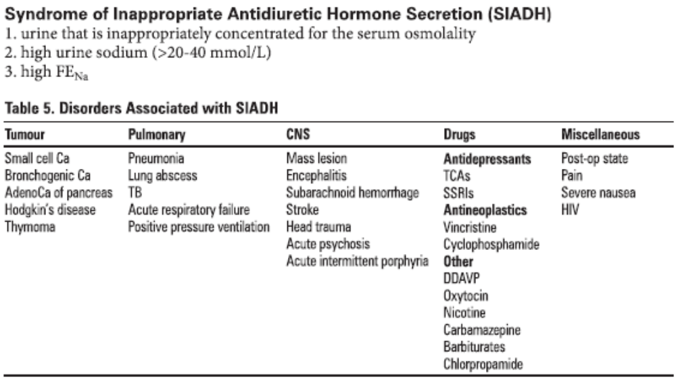
3. Hyponatremia with no (or minimal) urine
- advanced renal failure with oliguria may be associated with hyponatremia if the patient ingests even a moderate amount of dilute fluids

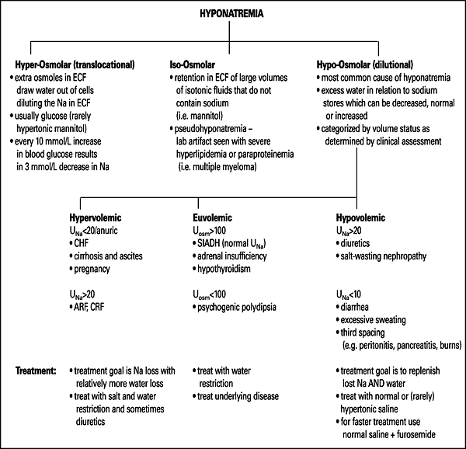

Ix
- ECF volume status assessment
- serum electrolytes, glucose, Cr
- serum osmolality
- urine osmolality
- urine Na <10-20 mmol/L suggests volume depletion as the cause of hyponatremia
- assess for causes of SIADH (see Table 5 below)
- thyroid function tests and cortisol levels
- if suspect pulmonary cause of SIADH consider CT chest

hypernatraemia
DEFINITIONS
- Too little water in the ECF relative to Na (can be in the context of normal, decreased or increased total body Na)
- serum [Na] >145 mmol/L
- Usually prevented by thirst and ADH release
- S&S: brain cell shrinkage (altered mental status, weakness, neuromuscular irritability, focal neuro deficits, seizures, coma, death) +/- polyuria, thirst, signs of hypovolaemia
- Complications: increased risk of vascular rupture resulting in intracranial hemorrhage, rapid correction may lead to cerebral edema due to ongoing brain hyperosmolarity
DDx
- Net water loss
  - Decreased intake (access to water, fluid restriction)
  - Increased loss (renal, extrarenal)
- (rarely due to gain of Na)
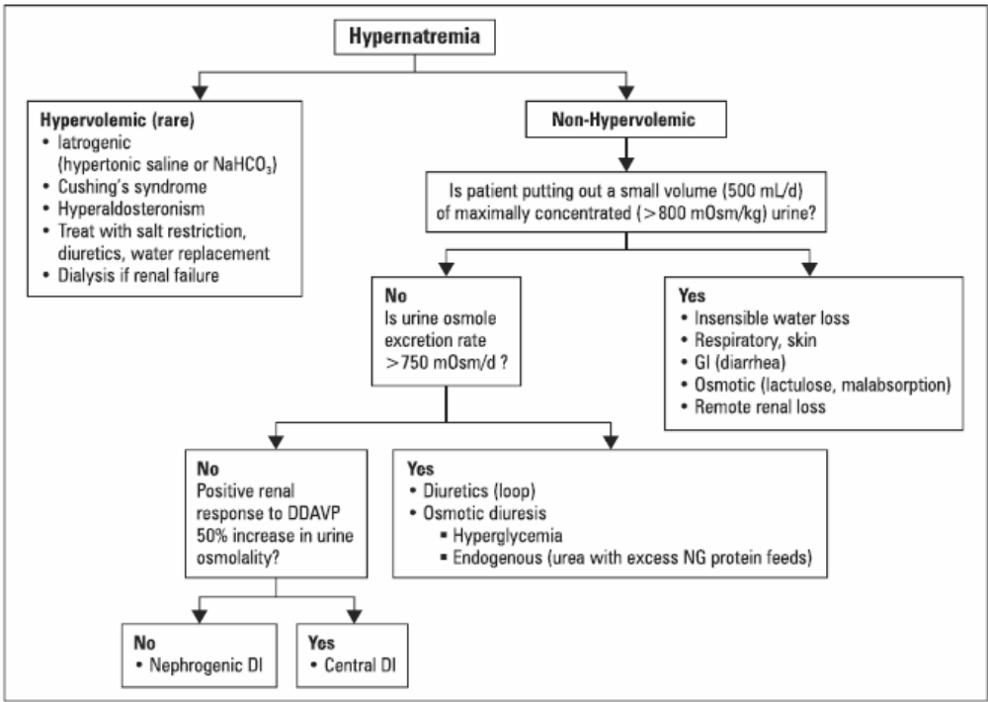
Ix
As above
Mx:
- general measures for all patients
  - give free water (ie. water without sodium). Oral/NG pure water best. If it must be IV, use low/no salt fluid eg. 5% dextrose, 0.45% NS
  - treat underlying cause
  - monitor serum Na frequently to ensure correction is not occurring too rapidly (aim to lower Na by max 12 mmol/L in 24 h – rule of thumb to achieve this: give 200mL/hour of free water)
- if evidence of hemodynamic instability, must first correct volume depletion with NS bolus
- loss of water is often accompanied by loss of Na but a proportionately larger water loss

hyper/hypokalaemia: see next section

C. MANAGEMENT OF RENAL EMERGENCIES

1. Describe the immediate treatment of a patient with a hypertensive crisis
Definitions
- Hypertensive emergencies are acute, life-threatening, and usually associated with marked increases in blood pressure (BP), generally ≥180/120 mmHg.
- A hypertensive emergency is considered to be present when severe hypertension is associated with acute end-organ damage.
- Examples include malignant hypertension, with or without hypertensive encephalopathy, subarachnoid or intracerebral hemorrhage, acute pulmonary edema, aortic dissection, and rebound after withdrawal of antihypertensive medications.
- Malignant hypertension is marked hypertension with retinal hemorrhages, exudates, or papilledema. There may also be renal involvement, called malignant nephrosclerosis.
- Hypertensive encephalopathy refers to the presence of signs of cerebral edema caused by breakthrough hyperperfusion from severe and sudden rises in blood pressure.
Management
Immediate but careful reduction in blood pressure is indicated in these settings. However, an excessive hypotensive response is potentially dangerous, possibly leading to ischemic complications such as stroke, myocardial infarction or blindness in some cases. Thus, in patients who are severely hypertensive but asymptomatic, slower reductions in blood pressure should be provided with oral agents.
- The initial aim of treatment in hypertensive crises is to rapidly lower the diastolic pressure to about 100 to 105 mmHg; this goal should be achieved within two to six hours, with the maximum initial fall in BP not exceeding 25 percent of the presenting value.
- Once the BP is controlled, the patient should be switched to oral therapy, with the diastolic pressure being gradually reduced to 85 to 90 mmHg over two to three months.
- The initial reduction to a diastolic pressure of approximately 100 mmHg is often associated with a modest worsening of renal function; this change, however, is typically transient as the vascular disease tends to resolve and renal perfusion improves over one to three months. Antihypertensive therapy should not be withheld in this setting unless there has been an excessive reduction in BP.
- A change in medication, however, is indicated if the decline in renal function is temporally related to therapy with an angiotensin (ACE) converting enzyme inhibitor or angiotensin II receptor blocker, which can interfere with renal autoregulation and produce acute renal failure in patients with bilateral renal artery stenosis.
Parenteral drugs
Vasodilators
- Sodium nitroprusside: dilates both arterioles and veins by providing NO. Generally considered to be the most effective parenteral drug for most hypertensive emergencies. IV infusion. Fast onset. Short acting.
- Nitroglycerin: Similar to nitroprusside, provides NO.
- Calcium channel blockers: Clevidipine, nicardipine
- Dopamine-1 receptor agonist: Fenoldopam. Its benefit is unlike other parenteral antihypertensives, it maintains or increases renal perfusion while it lowers BP.
- Hydralazine: direct arteriolar vasodilator with little–no effect on venous circulation. Main use is in pregnant and postpartum women.
Adrenergic blockers
- Alpha and Beta blocker: Labetalol
- Beta blocker: Esmolol
- Alpha blocker: Phentolamine. Used in hypertension related to catecholamine excess eg. phaeochromocytoma.

2. Recognise the dangerous consequences and describe the immediate treatment of a patient with acute

electrolyte disturbances, in particular hyperkalaemia and hypokalaemia

hyperkalaemia
- serum K >5.0 mEq/L

ECG Changes in Hyperkalemia
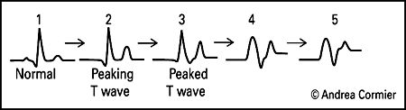

Signs and Symptoms
- usually asymptomatic but may develop nausea, palpitations, muscle weakness, muscle stiffness, paresthesias, areflexia, ascending paralysis, and hypoventilation
- impaired renal ammoniagenesis and metabolic acidosis
- ECG changes and cardiotoxicity (do not correlate well with K concentration)
  - peaked and narrow T waves
  - decreased amplitude and eventual loss of P waves
  - prolonged PR interval
  - widening of QRS and eventual merging with T wave (sine-wave pattern)
  - AV block
  - ventricular fibrillation, asystole

Approach to Hyperkalemia
1. emergency measures: obtain ECG, if life threatening begin treatment immediately
2. rule out factitious hyperkalemia; repeat blood test
3. hold exogenous K, and any K retaining medications
4. assess potential causes of transcellular shift
5. estimate GFR (calculate CrCl/use Cockcroft-Gault)
6. if normal GFR, calculate TTKG = (U_{k}/P_{k})/(U_{osm}/P_{osm})
TTKG <7 = decreased effective aldosterone function
TTKG >7 = normal aldosterone function

Causes of Hyperkalemia
Factitious | Increased Intake | Cellular Release | Decreased Excretion
Prolonged use of tourniquet  Sample taken from vein where IV KCl is running  Sample hemolysis  Leukocytosis (extreme)  Thrombocytosis (extreme) | Diet  KCl tabs  IV KCl | Intravascular hemolysis  Rhabdomyolysis  Insulin deficiency  Hyperosmolar states (e.g. hyperglycemia)  Metabolic acidosis (except for keto- and lactic acidosis)  Tumour lysis syndrome  Drugs  beta-blockers  Digitalis overdose (blocks Na-K ATPase)  Succinylcholine | Decreased GFR  renal failure  low effective circulating volume  NSAIDs in renal insufficiency  Normal GFR but hypoaldosteronism (see Table 7 below)
Causes of Hyperkalemia with normal GFR
Decreased Aldosterone stimulus (low renin, low aldosterone) | Decreased aldosterone production  (normal renin, low aldosterone) | Aldosterone resistance  (decreased tubular response)
Hyporeninemic, hypoaldosteronism  associated with DM2, NSAIDs, chronic interstitial nephritis, HIV | adrenal insufficiency of any cause [e.g. Addison’s disease, AIDS, metastatic cancer]  ACE inhibitors  Angiotensin II receptor blockers  Heparin  congenital Adrenal Hyperplasia with 21-hydroxylase deficiency | K-sparing diuretics  spironolactone  amiloride  triamterene  Drugs which mimic K-sparing diuretics  pentamidine  trimethoprim  cyclosporine, tacrolimus  Pseudohypoaldosteronism (rare inherited tubular disorders)

Treatment
- acute therapy is warranted if ECG changes present, K high, symptoms present
- tailor therapy to severity of increase in K and ECG changes
  - K <6.5 and normal ECG
    - treat underlying cause, stop K intake, increase the loss of K via urine and/or GI tract (see below)
  - K between 6.5 and 7.0, no ECG changes: add insulin to above regimen
  - K >7.0 and/or ECG changes: first priority is to protect the heart: add Ca gluconate to above

1. Protect the Heart
- Ca gluconate 1-2 amps (10 mL of 10% solution) IV
- antagonizes cardiac toxicity of hyperkalemia, protects cardiac conduction system, no effect on serum K
- onset within minutes, lasts 30-60 minutes
2. Shift K into Cells
- regular insulin (Insulin R) 10-20 units IV, with 1-2 amp D50W
  - onset of action 15-30 min, lasts 1-2 h
  - monitor blood glucose q1h
  - can repeat every 4-6 hours, or give infusion of 1 unit/hour
- NaHCO₃ 1-3 amps (given as 3 amps of 7.5% or 8.4% NaHCO₃ in 1L D5W)
  - onset of action 15-30 min, transient effect, drives K into cells in exchange for H
- beta₂-agonist (Ventolinâ„¢) in nebulized form (dose = 2 cc or 10 mg inhaled) or 0.5 mg IV
  - onset of action 30-90 min, stimulates Na-K ATPase
  - caution if patient has heart disease as tachycardia may result from this high dose of beta₂-agonist
3. Enhance K Removal from Body
- A. via urine
  - furosemide (>40 mg IV), may need IV NS to avoid hypovolemia
  - fludrocortisone (synthetic mineralocorticoid) if suspect aldosterone deficiency
- B. via gut
  - cation-exchange resins: calcium resonium or Kayexalateâ„¢ (less preferred because it binds Na in exchange for K) plus sorbitol PO to avoid constipation
  - Kayexalateâ„¢ enemas with tap water (not sorbitol)
- C. dialysis (renal failure, life threatening hyperkalemia unresponsive to therapy)

hypokalaemia
- serum K <3.5 mEq/L

Approach to Hypokalemia
- 1. emergency measures: obtain ECG; if potentially life threatening begin treatment immediately
- 2. rule out transcellular shifts of K as cause of hypokalemia
- 3. assess contribution of dietary K intake
- 4. 24h K excretion or spot urine K
- 5. TTKG = transtubular potassium gradient = (U_{k}/P_{k})/(U_{osm}/P_{osm})
- 6. if renal K loss, check BP and acid-base status
- 7. may also assess plasma renin and aldosterone levels, serum Mg

Signs and Symptoms
- usually asymptomatic, particularly when mild (3.0-3.5 mmol/L)
- nausea, vomiting, fatigue, generalized weakness, myalgia, muscle cramps, constipation
- if severe: arrhythmias, muscle necrosis, and rarely paralysis with eventual respiratory impairment
- arrhythmias occur at variable levels of K; more likely if: digoxin use, hypomagnesemia, CAD
- ECG changes are more predictive of clinical picture than K levels
  - U waves most important
  - flattened or inverted T waves
  - depressed ST segment
  - prolongation of Q-T interval
  - with severe hypokalemia: P-R prolongation, wide QRS, arrhythmias; increases risk of digitalis toxicity

EKG Changes in Hypokalemia
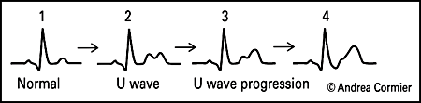
Treatment
- treat underlying cause
- if urine output and renal function are impaired, correct with extreme caution
- risk of hyperkalemia especially high in elderly, diabetics, and patients with decreased renal function
- beware of excessive potassium repletion, especially if transcellular shift caused hypokalemia
- if true K deficit, potassium repletion (decrease in serum K of 1 mEq is approximately 100-200 mEq total body loss)
  - oral sources â€“ food, tablets (K-Durâ„¢), KCl liquid solutions
  - IV â€“ usually KCl in saline solutions, avoid dextrose solutions (exacerbate hypokalemia via insulin release)
  - max 40 mmol/L via peripheral vein, 60 mmol/L via central vein, max infusion 20 mmol/hr
- K-sparing diuretics (triamterene, spironolactone, amiloride) can prevent renal K loss
- restore Mg if necessary

Figure 11. An Approach to Hypokalemia
* TTKG = Trans-Tubular K Gradient
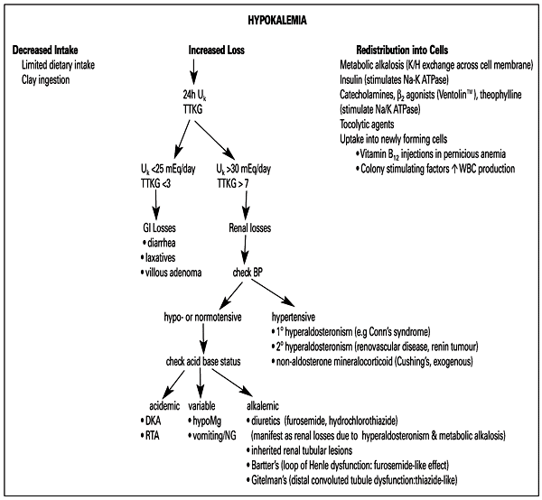

3. Recognise the clinical features of fluid overload and dehydration and discuss management of both presentations
 | Dehydration (signs occuring with ≥5% loss) | Fluid overload
BP | Orthostatic drop | Normal/increased
JVP | Low | High
Heart | Tachycardia | S3
Lungs | Normal | Pulmonary oedema and pleural effusion: inspiratory crackles, SOB, orthopnoea
Skin turgor | Decreased | Normal/increased
Dependent oedema | No | Yes
Urine output | Low | Variable
Body weight | Decreased | Increased
Mucous membranes | Dry | Moist
Groin/axilla | Dry | Moist
Haematocrit, Hb, serum protein, urea | Low | High
Indications for acute dialysis:
1. Refractory pulmonary oedema
2. Persistent hyperkalaemia >7 mmol/L
3. Severe metabolic acidosis (pH <7.1 or BE <10)
4. Signs of uraemia (pericarditis, encephalopathy)
5. Some toxins
Dehydration:
- Fluid resuscitation
- Treat cause

Fluid overload:
- Pulmonary oedema/heart failure management
  - Sit up, high flow O2 by mask
  - Venous vasodilator eg. morphine 2.5 mg IV
  - Frusemide 120-150 mg IV over 1 hour (patients without renal failure need lower doses than this)
  - GTN: spray 2 puffs or 2 sublingual tablets. Then nitrate infusion (not if systolic BP <100 mmHg).
  - If no response, urgent haemodialysis
  - Consider CPAP
  - Consider venesection (100-200 mL) if the patient is in extremis
  - CXR: bilateral shadowing, blunted costophrenic angles, fluid in fissures, Kerley B lines

4. Recognise the clinical features of an emergency presentation of rapidly progressive glomerulonephritis

and explain the role of early aggressive treatment in this clinical scenario

RAPIDLY PROGRESSIVE GLOMERULONEPHRITIS (RPGN)
Clinical/Lab Features
- a presentation of a number of primary and secondary glomerulonephropathies in which renal failure progresses in weeks to months
- usually crescent formation seen on renal biopsy
- RBC casts and/or dysmorphic RBCs in urine
- classified by immunofluorescence staining
- treatment: corticosteroids + cyclophosphamide or other cytotoxic agent + plasmaphoresis in select cases
- prognosis: 50% recovery with early treatment, depends on underlying cause
Table 10. RPGN Classification
 | RPGN Type I: Anti-GBM mediated | RPGN Type II: Immune Complex mediated | RPGN Type III: Non-immune mediated (i.e. pauci-immune)
% of RPGN cases | 15% of cases | 24% of cases | 60% of cases
Immuno-fluorescence staining pattern | Linear pattern due to IgG and C3 deposition along capillary loops | Granular pattern due to subendothelial or subepithelial deposits of IgG and C3 | No immune staining
Pathogenesis | Antibodies against type IV collagen in GBM | Most often 2º to systemic disease | Vasculitis of glomerular capillaries
Primary causes | Idiopathic anti-GBM disease | IgA nephropathy | Idiopathic
Secondary causes | Goodpasture’s disease | Post-infectious GN, SLE, cryoglobulinemia, Henoch-Schonlein purpura | Wegener’s (c-ANCA +ve), microscopic polyangiitis (p-ANCA +ve), Churg-Strauss (ANCA â€“ve)

5. Discuss the indications for dialysis in acute kidney injury
See next section for management of AKI

D. IMPORTANT RENAL CONDITIONS

1. Acute Kidney Injury (AKI) - previously known as Acute Renal Failure
Definition: Acute (over hours-days) deterioration in renal function, characterised by a rise in serum creatinine and urea, often with oliguria or anuria.

(a) Provide examples of the common causes of Acute Kidney Injury (AKI)
- The 2 most common causes of acute kidney injury in hospitalized patients are prerenal causes and acute tubular necrosis. Remember that prerenal failure can lead to ATN
- Important causes to consider: hypovolaemia, low cardiac output, sepsis, drugs, obstruction.
- See previous section for ddx of AKI

(b) Outline the management of the consequences of AKI:
General principles of emergency management of AKI:
1. Treat the precipitating cause (transfuse if acute bleeding,
2. Treat life-threatening hyperkalaemia
3. Treat pulmonary oedema, pericarditis and tamponade
4. Treat volume depletion, if present
5. Treat sepsis
6. Further diagnostic workup

Remember the indications for acute dialysis (see box previous section)

i. fluid overload
For pulmonary oedema management see C.3.
Uraemic pericarditis/pericardial tamponade management:
- As for tamponade from other causes
- Signs: Beck’s triad: falling BP, rising JVP and muffled heart sounds. Kussmaul’s sign: increase in JVP on inspiration. Pulsus paradoxus: pulse fades on inspiration.
- Ix: CXR: globular heart, left heart border convex or straight, right cardiophrenic angle <90 deg. Echo may be diagnostic.
- O2, monitor ECG, IV access.
- Urgent pericardiocentesis.

ii. electrolyte abnormalities
- hyperkalemia (see previous section)

iii. acid-base disturbances
- Correct acidosis with sodium bicarbonate eg. 50 mL of 8.4% IV

(c) Discuss the urine, blood and imaging investigations required to diagnose and manage AKI
See previous section on AKI

Clinical Pearl
Clues to Pre-Renal Etiology  - clinical: decreased BP, increased HR,  positive orthostatic HR & BP changes  - increased [urea] >> increased [Cr]  - urine [Na] <10-20 mmol/L  - urine osmolality > 500 mOsm/kg  - fractional excretion of Na < 1% | Clues to Renal Etiology  - appropriate clinical context  - urinalysis positive for casts:  - pigmented granular â€“ ATN  - WBC â€“ AIN  - RBC â€“ GN | Clues to Post-Renal Etiology  - known solitary kidney  - older man  - recent retroperitoneal surgery  - anuria  - palpable bladder  - ultrasound indicates hydronephrosis
Clinical Pearl
Differentiating Pre-renal from ATN

 | Pre-renal | ATN
Urinalysis | normal | RBC, pigmented granular casts
Urine [Na] | <20 | >40 mEq/L
Urine [Cr]/[Na] | >40 | <20
Urine osmolality | >500 | <350 mOsm/kgH₂O
Fe_{Na} | <1 | >1

- Chronic Kidney Disease (CKD) – previously known as Chronic Renal Failure
  - Outline the staging of CKD (Stages 1 to 5) according to Glomerular Filtration Rate
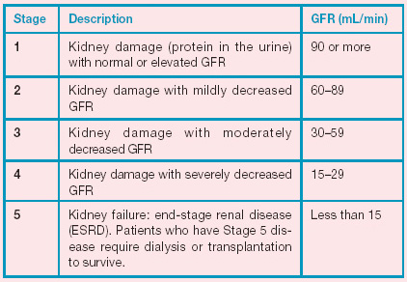
  - Provide examples of the common causes of CKD in the Australian population
The three top causes of kidney failure in Australia are:
- Diabetes - 34% of new cases
- Nephritis or inflammation of the kidney - 22% of new patients
- High blood pressure (hypertension) - 15% of new cases
  - Outline the epidemiology of CKD in Indigenous Australians and the impact this has on clinical presentation
- An estimated 1.5%( 7,500) of Indigenous Australians have kidney disease as a long-term health condition based on self-reported data (AIHW: Penm 2008).
- Of the 2,311 people commencing kidney replacement therapy in 2007, 218 (9%) identified as Aboriginal or Torres Strait Islander, although Indigenous Australians made up only 2.5% of the total population.
- At the end of 2007, there were 1,213 Indigenous Australians receiving treatment for their ESKD (7.2% of all treated ESKD)
- The median age at death from CKD as the underlying cause among Indigenous Australians was 60 years for males and 62 years for females, compared with 82 years and 84 years among non Indigenous Australian males and females respectively.
  - List the conditions that are associated with an increased risk of developing CKD and describe how these risks can be modified
- Adult Australians are at risk of CKD if they:
  - Have high blood pressure (hypertension)
  - Have diabetes
  - Smoke cigarettes
  - Are obese (BMI>=30)
  - Outline the principles of slowing the progression of CKD to End Stage Kidney Disease (ESKD) with reference to the control of diabetes, blood pressure and proteinuria, and including the role of drugs that interfere with the RAAS
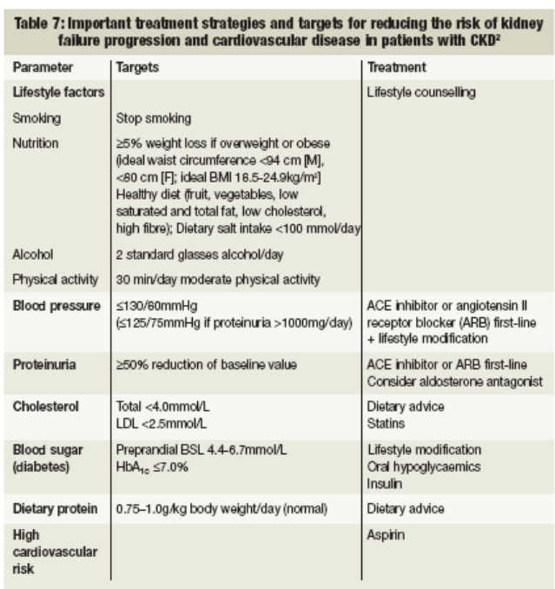
  - Identify and manage common clinical complications of CKD, such as fluid overload, hypertension, anaemia
NEPHRON
N - Low-nitrogen diet
E - Electrolytes: monitor K
P- pH: mebbolic acidosis
H – Hypertension; ACEI for hypertension (target 130/80 or less), loop diuretics when GFR <25 rnUmin
R - RBCs: mNge anemia with erythropoiatin
O - Osteodystrophy: give calcium between meals to increase Ca and with mealt (to bind and decrease PO4)
N – Avoid nephrotoxic drugs[ASA, gentamicin) and adjust doses of renally excreted medication
(g) Outline the management of the following biochemical consequences of CKD:
i. hyperkalaemia [Toronto notes]
Treatment of Hyperkalemia
SEE BIG KDROP
SEE - Calcium gluconata
BIG - Beta-block. Bicarb, Insulin, Glucose
K - Kareyexalate (resonium)
DROP - Diuretics, dialysis
ii. Hyperphosphataemia
- Hyperphosphatemia due to renal failure is predominantly treated by limiting ingested quantities and by dialysis
- Phosphate binders (aluminium-containing, calcium-containing, sevelamer)
- Control of secondary hyperparathyroidism
iii. metabolic acidosis
- treat underlying cause
  - insulin for DKA
  - restore tissue perfusion for type A lactic acidosis
  - ethanol + dialysis for methanol or ethylene glycol poisoning
  - alkaline diuresis ± dialysis if ASA overdose
- correct coexisting disorders of K (see Hyperkalemia)
- consider treatment with exogenous alkali (e.g. NaHCO,) if:
  - severe reduction in [HC03] e.g. <8 mmol/L, especially with very low pH ( <7)
  - no metabolizable anion (e.g. salicylate, formate, oxalate, sulphat
  - Describe how CKD affects the production of the following hormones, and how you would manage these disturbances:
i. erythropoetin
ii. 1,25 dihydroxy vitamin D
iii. parathyroid hormone

- A normocytic, normochromic anemia is observed as early as stage 3 CKD and is almost universal by stage 4. The primary cause in patients with CKD is insufficient production of EPO
  - Additional factors include iron deficiency, acute and chronic inflammation, severe hyperparathyroidism with consequent bone marrow fibrosis, and shortened red cell survival in the uremic environment.
- Treatment: EPO plus substrates for RBC production (Fe, Vitamin B12, folate); erythropoietin injections (Hct <30%) for anemia; target Hct 33-36%
- Treatment of Vitamin D deficiency; consider calcitriol (1,25-dibydroxy-vitamin D) if hypocalcemic
- Treatment of HyperPTH:
  - sevelamer (phosphate binder) if both hypercalcemic and hyperphosphatemic
  - cinacalcet for hyperparathyroidism (sensitizes parathyroid to Ca, decreasing PTH)

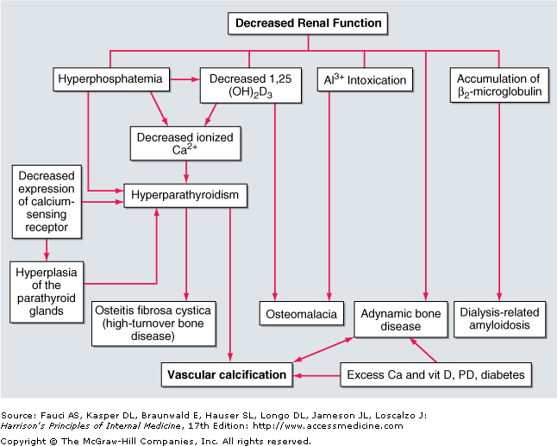
- End-stage Kidney Disease (ESKD) - previously known as Endstage Renal Failure
(a) List the common causes of ESKD in Australia
Glomerulonephritis (30%)
DM (25%)
Hypertension (5%)
PKD, VUR, analgesic nephropathy (5% each)
(b) Explain the indications for dialysis therapy
- absolute indications
  - volume overload unresponsive to medication
  - hyperkalemia unresponsive to medication
  - severe metabolic acidosis unresponsive to medication
  - neurologic signs or symptoms of uremia (encephalopathy, neuropathy, seizures)
  - uremic pericarditis
  - refractory accelerated hypertension
  - clinically significant bleeding diathesis
  - persistent severe nausea and vomiting
  - plasma Cr >1060 IUDOl!L (12 mg/dL) or BUN >36 mmol/L (100 mg/dL; clinical picture also important)
- HAVE PEE
  - HyperK+ (refractory)
  - Acidosis (refractory)
  - Volume overload (refractory)
  - Elevated Urea (>35mM)
  - Pericarditis
  - Encephalopathy
  - Edema (pulmonary)
(c) Outline the principles of preparation for ESKD treatment, including access for peritoneal or haemodialysis, and investigation for suitability for kidney transplantation (including kidney donation by a living relative) [Harrison’s]
Access for dialysis
- Peritoneal dialysis
  - Access through peritoneal catheter. Catheters are flexible, made of silicon rubber with numerous side holes at the distal end. These catheters usually have two Dacron cuffs to promote fibroblast proliferation, granulation, and invasion of the cuff. The scarring that occurs around the cuffs anchors the catheter and seals it from bacteria tracking from the skin surface into the peritoneal cavity; and prevents the external leakage of fluid from the peritoneal cavity. The cuffs are placed in the preperitoneal plane and ~2 cm from the skin surface.
- Haemodialysis
  - The fistula, graft, or catheter through which blood is obtained for hemodialysis is often referred to as a dialysis access. A native fistula created by the anastomosis of an artery to a vein (e.g., the Brescia-Cimino fistula, in which the cephalic vein is anastomosed end-to-side to the radial artery) results in arterialization of the vein. This facilitates its subsequent use in the placement of large needles (typically 15 gauge) to access the circulation.
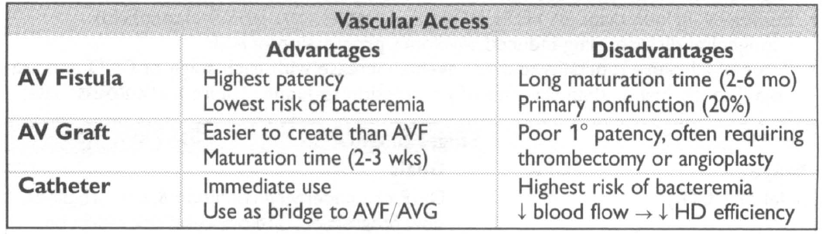
Transplants
- Recipients:
  - aggressive approach to diagnosis of correctable coronary artery disease, presence of latent or indolent infection (HIV, hepatitis B or C, tuberculosis), and neoplasm should be a routine part of the candidate workup.
  - HIV and active hepatitis are absolute contraindications to transplantation because of the high risk of opportunistic infection.
  - presence of a potentially harmful antibody against the donor kidney at the time of the anticipated transplant. Harmful antibodies that can cause very early graft loss include natural antibodies against the ABO blood group antigens and antibodies against human leukocyte antigen (HLA) class I (A, B, C) or class II (DR) antigens. These antibodies are routinely excluded by proper screening of the candidate's ABO compatibility, HLA typing of donor and recipient, and direct cross-matching of candidate serum with lymphocytes of the donor.
- Donors (living)
  - Grafts have better survival from living relatives (5-7% greater 1 year survival vs. cadaveric grafts) for even partially matched kidneys (3/6 HLA match)
  - Must be normal on physical examination
  - Same ABO group as recipient (or group O)
  - Renal arteriography to determine presence of abnormal renal vessels
  - Free of malignant disease/ hepatitis/ HIV
- Deceased donor
  - Increased risk of graft failure exists when the donor is elderly or has renal failure and when the kidney has a prolonged period of ischemia and storage.
- Explain the principles of peritoneal dialysis and haemodialysis to a patient and where they can be performed
 | Peritoneal Dialysis | Haemodialysis
Rate | Slow | Fast
Location | Home | Hospital (usually)
Ultrafiltration | Osmotic pressure via dextrose diasylate | Hydrostatic pressure
Solute Removal | Concentration gradient and convection | Concentration gradient and convection
Membrane | Peritoneum | Semi-permeable membrane
Method | Indwelling catheter in peritoneal cavity | Line from vessel to artificial kidney
Complications | Infection at catheter site, bacterial peritonitis, metabolic effects of glucose, difficult to achieve adequate clearance in patients with large BMI | Vascular access (clots, collapse, bacteraemia, bleeding due to heparin, haemodynamic stress, disequilibrium syndrome (hypotension, nausea, cramps)
Preferred When | Young, high functioning, residual renal function | Bed-bound, comorbidities, no renal function

- Discuss the limitations of dialysis therapy in replacing the functions of the normal kidney and describe the additional therapies that are often required
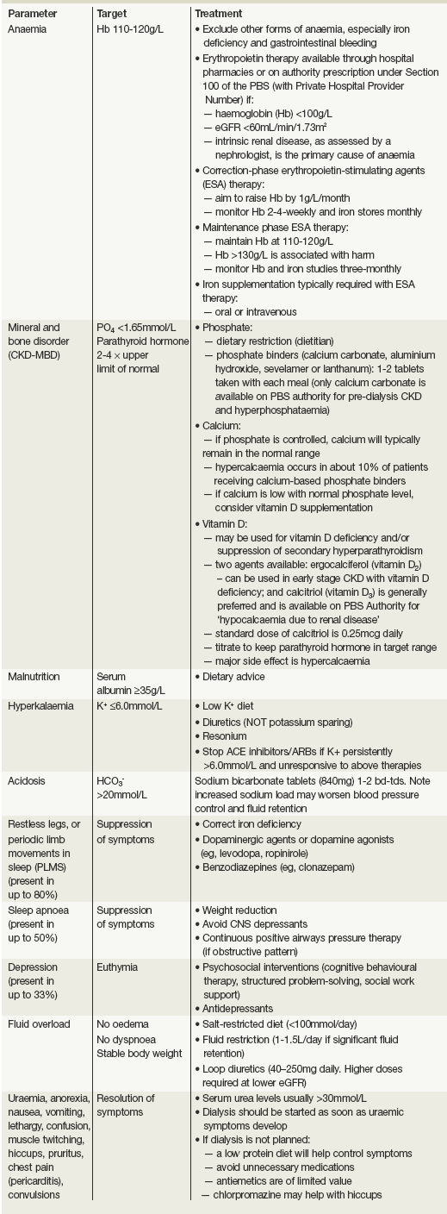
- Describe to a patient the principles of immunosuppression and its complications following kidney transplantation [Harrison’s]
- Supression of all immune responses, including those to bacteria, fungi and malignant tumours- more selective to primary vs. memory immune responses
  - Incidence of malignancy 100x greater than in the general population (5-6%)
    - Cancer of lips, skin, cervix, lymphoma
    - Opportunistic infections
      - Wound infections, HSV, oral candidiasis, UTIs, CMV, legionella, Listeria, Hep B & C, Herpes Zoster, Aspergillus
- Drugs
  - Azathioprine
    - Inhibits synthesis of DNA and RNA
  - Mycophenolate mofetil
    - Similar mode of action to azathioprine
  - Glucocorticoids
    - Adjuncts to immunosuppressive therapy
    - Action on monocyte-macrophage system (IL-1 and IL-6)
    - Many side effects
  - Cyclosporine
    - Fungal peptide which blocks transcription of mRNA for IL-2 and other pro-inflammatory cytokines, thereby inhibiting T-cell proliferation
  - Tacrolimus and Sirolimus
    - Fungal macrolide – similar MOA to cyclosporine
- Compare the outcomes of dialysis therapy and kidney transplantation with regard to quality of life and survival [Harrison’s]
- Transplant vs. dialysis
  - Mortality
    - rates after transplant highest in the first year (3-7%)
    - These rates are better than those in the chronic dialysis population
  - QOL
    - Higher opportunistic infections (above)
    - Higher malignancy
    - Hypercalcaemia
    - HT
- Discuss the issue of opting for conservative (non-dialytic) treatment, particularly in elderly patients with significant comorbidities
- Glomerulonephritis
  - Recall the structure and function of the glomerulus

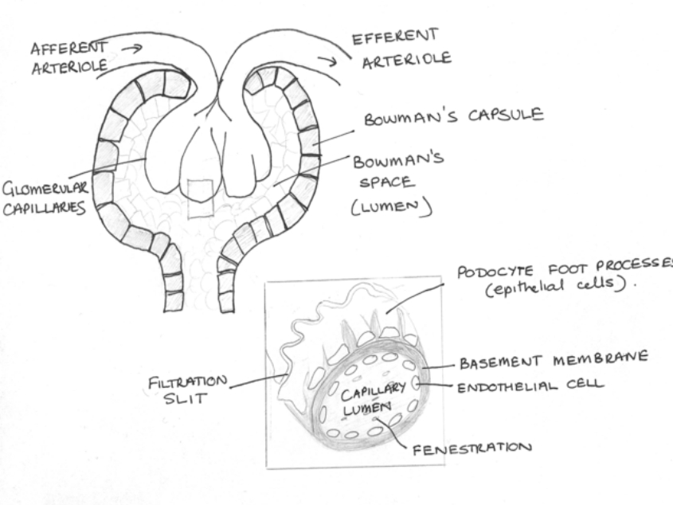
- A modified capillary network which delivers ultrafiltrate of plasma to Bowman’s space (proximal part of the renal tubule)
- 1.6 million glomeruli in the two adult kidneys producing 120- 180L of ultrafiltrate daily
- GFR is dependant on afferent and efferent arteriolar tone (for filtration pressure) and mesangial cell contractility (for filtration surface area)
- Golmerular endothelium is also antithrombotic and antiadhesive for leukocytes and platelets → prevention of thrombosis during filtration
- Glomerular filtration barrier prevents filtration of plasma proteins and blood cells
- Glomerular injury results in the impairment of glomerular filtration and/or the inappropriate appearance of plasma proteins and blood cells in the urine
  - Describe the major clinical syndromes of glomerular disease (nephrotic syndrome, nephritic syndrome, asymptomatic urinary abnormalities, rapidly progressive glomerulonephritis and chronic glomerulonephritis) and be able to list common causes of each
- Nephritic syndrome- Inflammatory glomerulonephropathies
  - Clinical features (PHAROH)
    - Proteinuria <3g/day
    - Abrupt onset Haematuria (microscopic of macroscopic)
    - Azotemia (increased Cr and urea)
    - RBC cases and/or dysmorphic RBCs in urine
    - Oliguria
    - Hypertension (due to salt and water retention)
  - Common causes
    - Low complement level
      - Post infectious GN
      - Membranoproliferative GN
      - Secondary to;
        - SLE, endocarditis, cryoglobulinaemia
    - High complement level
      - IgA nephropathy
      - Anti-GBM disease
      - Secondary to;
        - Polyarteritis nodosa, Wegener’s Henoch-Schonlein purpura, Goodpasture’s
- Nephrotic syndrome- affect glomerular filtration barrier for proteins (GBM and visceral epithelial cells)
  - Clinical features
    - Proteinuria >3g/day
    - Hypoalbuminaemia
    - Oedema
    - Hyperlipidaemia, lipiduria, fatty casts and oval fat bodies on microscopy
    - Hypercoagulable state
    - Pathology on renal biopsy
  - Common causes
    - Minimal change disease
    - Membranous nephropathy
    - Focal Segmental Glomerulosclerosis
    - Membranoproliferative glomerulonephritis
- Asymptomatic urinary abnormalities
  - Clinical features
    - Isolated proteinuria <2g/day and/or;
    - Isolated microscopic or macroscopic haematuria
  - Common causes
    - Proteinuria;
      - Postural
      - Herald onset of more serious GN
    - Haematuria + proteinuria
      - IgA nephropathy (presents after URTI)
      - Alport’s disease (hereditary nephritis): X linked nephritis often associated with sensorineural hearing loss
      - Thin Basement Membrane Disease (autosomal dominant, benign)
      - Benign recurrent haematuria; associated with febrile illness, exercise or immunization
- Rapidly progressive GN
  - A subset of nephritic syndrome in which renal failure progresses in weeks- months
  - Clinical features
    - Crescent formation seen on renal biopsy
    - RBC casts/ dysmorphic RBCs in urine
    - Classified by IF staining
  - Common causes;
    - Commonest (60%) due to a vasculitis of glomerular capillaries (idiopathic or secondary to wegener’s, microscopic polyangitis, Churg-Strauss)
    - Second commonest (24%) due to IgA nephropathy
    - Third commonest (15%) due to idiopathic anti-GBM disease or Goodpastures
  - Outline the general approach to investigating suspected glomerulonephritis
- Bloods
  - First presentation: electrolytes, Cr, urea, albumin, fasting lipids
  - Determining aetiology: CBC, ESR, serum electrophoresis, C3, C4, ANA, p-ANCA, c-ANCA, cryoglobulins, HBV, HCV serology, ASOT, VDRL, HIV
- Urinalysis: RBCs, WBCs, casts, protein
- Urine electrophoresis for Bence Jones proteins if proteinuria present (suggestive of multiple myeloma or Waldenstrom's macroglobulinemia)
- 24 hour urine for protein and CrCl
- Radiology
  - CXR (infiltrate, CHF, pleural effusion)
  - Renal ultrasound
- Renal biopsy
  - Outline the principles of “non-specific” treatment of glomerulonephritis
- [Harrison’s] Treatment is determined based on underlying diagnosis.
- General principles
  - Treat infection, if present.
  - Consider immunosuppressive therapy.
  - Treat hypertension and volume overload.
  - Perform renal replacement therapy or transplantation in patients with end-stage renal disease (ESRD).
  - Describe the importance of hypertension and proteinuria as causes of progressive renal failure
- Glomerular HT is an adaptive response to increase workload in remaining nephrons when others are damaged
- Sustained glomerular HT stimulates mesangial matrix production and glomerulosclerosis (thus further injuring the glomerulus)
- Glomerular hyperfiltration also associated with glomerulosclerosis
- These manifest clinically as proteinuria, HT and progressive renal insufficiency
  - Outline the prognosis of the main types of glomerulonephritis, and how to monitor their progression

- Inherited Kidney Disease
  - Describe the renal and extra-renal manifestations of Autosomal Dominant Polycystic Kidney Disease (ADPKD)
- Often asymptomatic; discovered incidentally on imaging or by screening
- Hematuria (initially microscopic)
- Nocturia (urinary concentrating defect)
- Rarely extra-renal presentation (ruptured berry aneurysm due to HT)
- HTN (increased rennin due to focal compression of intrarenal arteries by cysts) – 60- 75%
- Palpable kidneys
  - Outine the clinical course, diagnosis and management of ADPKD, including cerebral aneurysm
- Clinical course
  - Bilateral
  - Clinical manifestations rare <25 years
  - Kidneys normal size at birth but grow to 10 times normal
  - Variable progression to renal impairment (ESRT in up to 50% by age 60
- Diagnosis
  - Radiographic: renal U/S (showing enlarged kidneys, cysts in renal parenchyma, increased cortical thickness, splaying of renal calyces) or CT for equivocal cases
  - Gene linkage for PKD1 for asymptomatic carriers
  - Cr, BUN, urine R&M to assess for hematuria
- Management
  - Education and genetic counseling
  - Prevention and treatment of UTIs
  - Hydration to prevent stone formation
  - Avoidance of contact sports
  - Screen for cerebral aneurysms if family history
  - Monitor and treat HT
  - Dialysis or transplant for ESKD

- Hypertension
  - State the criteria for making a diagnosis of hypertension (eTG)
Reading of >140/90 on more than 1 occasion, with the patient relaxed;
Category | Systolic (mm Hg) | Diastolic (mm Hg)
normal | <120 | <80
high-normal | 120 to 139 | 80 to 89
grade 1 (mild) hypertension | 140 to 159 | 90 to 99
grade 2 (moderate) hypertension | 160 to 179 | 100 to 109
grade 3 (severe) hypertension | ≥180 | ≥110
isolated systolic hypertension | ≥140 | ≤90
  - Describe the relationship between blood pressure, cardiac output and peripheral resistance
BP = CO x TPR
  - Discuss in general terms the mechanisms whereby abnormalities of the kidney or its blood supply can lead to hypertension [Medscape]
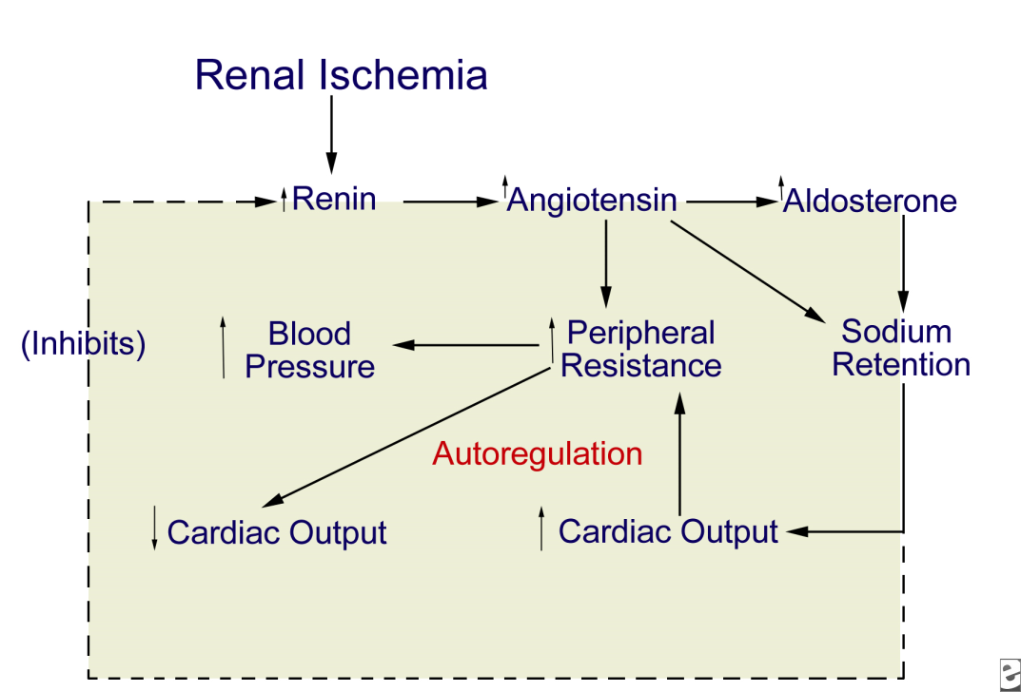
- Unilateral renal ischemia initiates hypersecretion of renin, which accelerates conversion of angiotensin I to angiotensin II and enhances adrenal release of aldosterone.
- The result is profound angiotensin-mediated vasoconstriction and aldosterone-induced sodium and water retention.
- In the 2-kidney 1-clip model, where the clinical correlate is unilateral renal artery disease, sodium and water handling via pressure diuresis of the contralateral kidney may be sufficient to prevent a volume component to the hypertension.
- In the setting of a solitary kidney (experimentally, the 1-kidney 1-clip model), sodium and water handling is compromised, sodium and water retention ensues, and volume-mediated hypertension occurs.
  - Classify hypertension according to:
i. causes: essential; secondary (renal, endocrine, pregnancy-related)
- Idiopathic (no known cause) in ~95% of patients (‘essential’ HT)
- Secondary to known disease in ~5%
      - Renovascular 2-3%
      - Parenchymal 1-2%
      - Endocrine hypertension
      - Primary Aldosteronism 0.3%
      - Cushing’s Syndrome <0.1%
      - Phaeochromocytoma <0.1%
      - Oral Contraceptive 0.5-1%
      - Other 0.2%
ii. severity: benign, accelerated, malignant
- Benign - stable for years
- Malignant - >200/120 mm Hg - 1-2 year course
      - Rapid rise in bp to 200/120mmHg
      - Accompanied by severe headaches, shortness of breath, chest pain
      - Severe organ damage – myocardial and cerebral infarction, stroke, hemorrhage, etc.
- Describe how you would investigate a patient with (a) newly diagnosed hypertension, (b) early onset hypertension and (c) resistant hypertension.
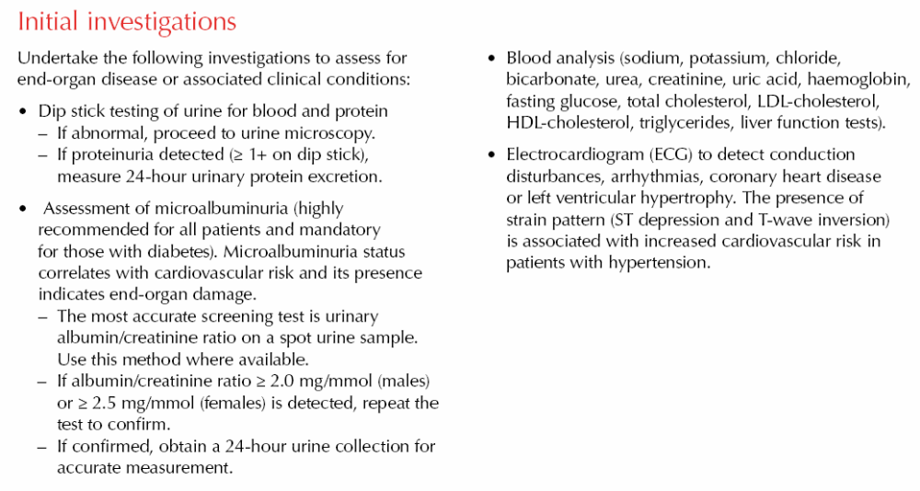
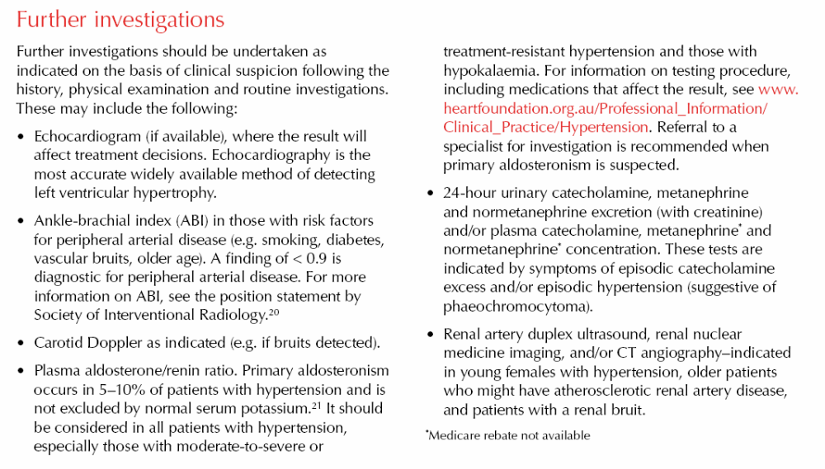

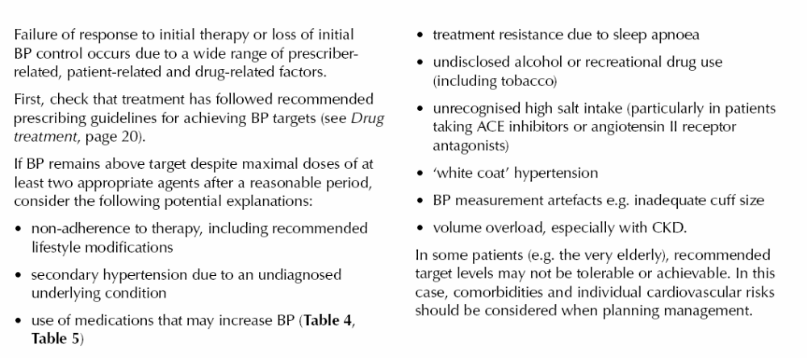
  - Describe
i. the pathology of end organ damage due to untreated hypertension in small blood vessels, kidneys, heart, brain and retina [Lecture Stage 2]
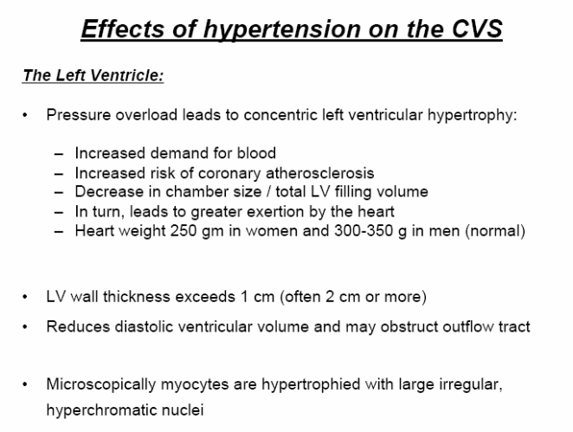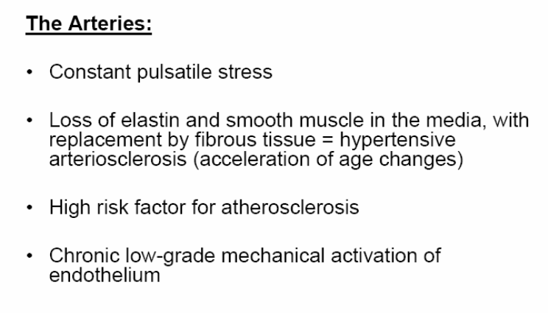
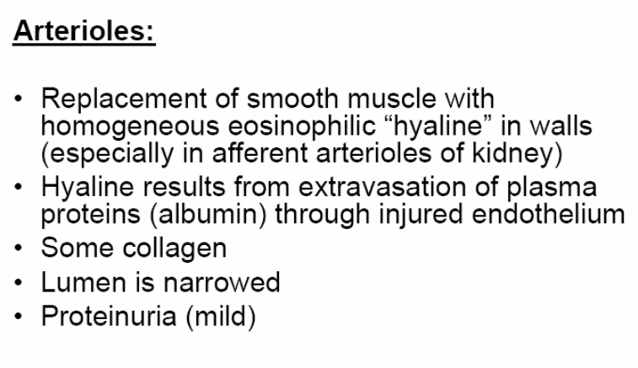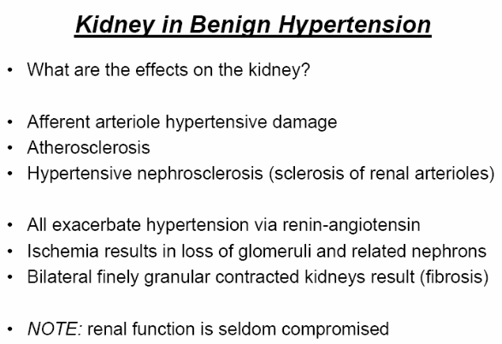
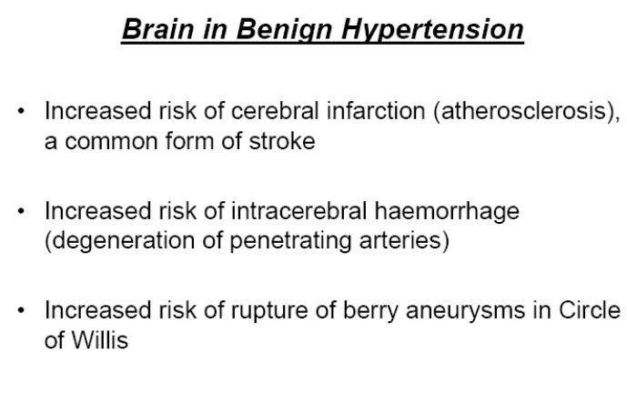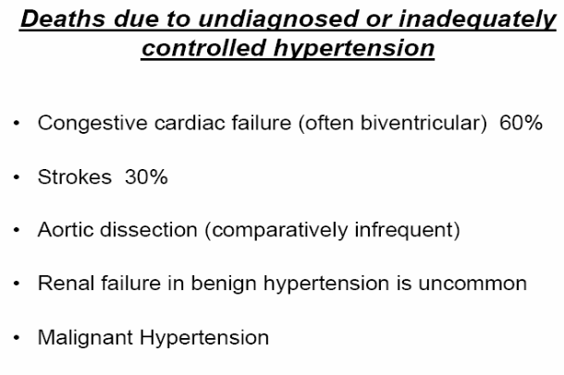
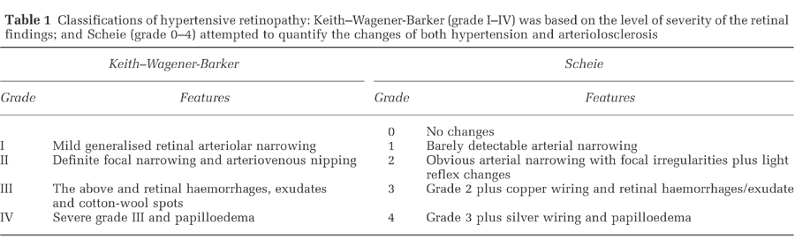
ii. how to investigate for evidence of end organ damage
iii.how to monitor the effect of treatment
- Main focus is on the heart and kidneys
  - UA (screen for renal parenchymal disease)
  - EUCs (renal function)
  - Blood glusocse (vascular risk factor)
  - Lipid profile (vascular risk factor)
  - CXR (heart borders)
  - ECG (LVH)
  - Describe the non-pharmacological management of hypertension [Heart Foundation Guidelines]
Regular Physical Activity
- 30 minutes on most/ all days
Smoking Cessation
- Consider pharmacotherapy for those who smoke >10/day
Dietary modification
- Salt restriction < 4g/day (65mmol/day sodium)
- Avoid salty/ processed foods
- In patients with normal renal function: increase K+ intake
- Patients taking potassium sparing diuretics must limit potassium intake
Weight Reduction
- Waist circumference < 94cm in males and <80cm in females
- BMI < 25
Limit alcohol intake
- 2 per day for men; 1 per day for women
- 2 alchohol free days/ week

  - Outline the principles of the pharmacological management of hypertension, including when to initiate, the main classes of drugs (including their side effects and reasons for favouring or avoiding particular classes) and combination therapy.
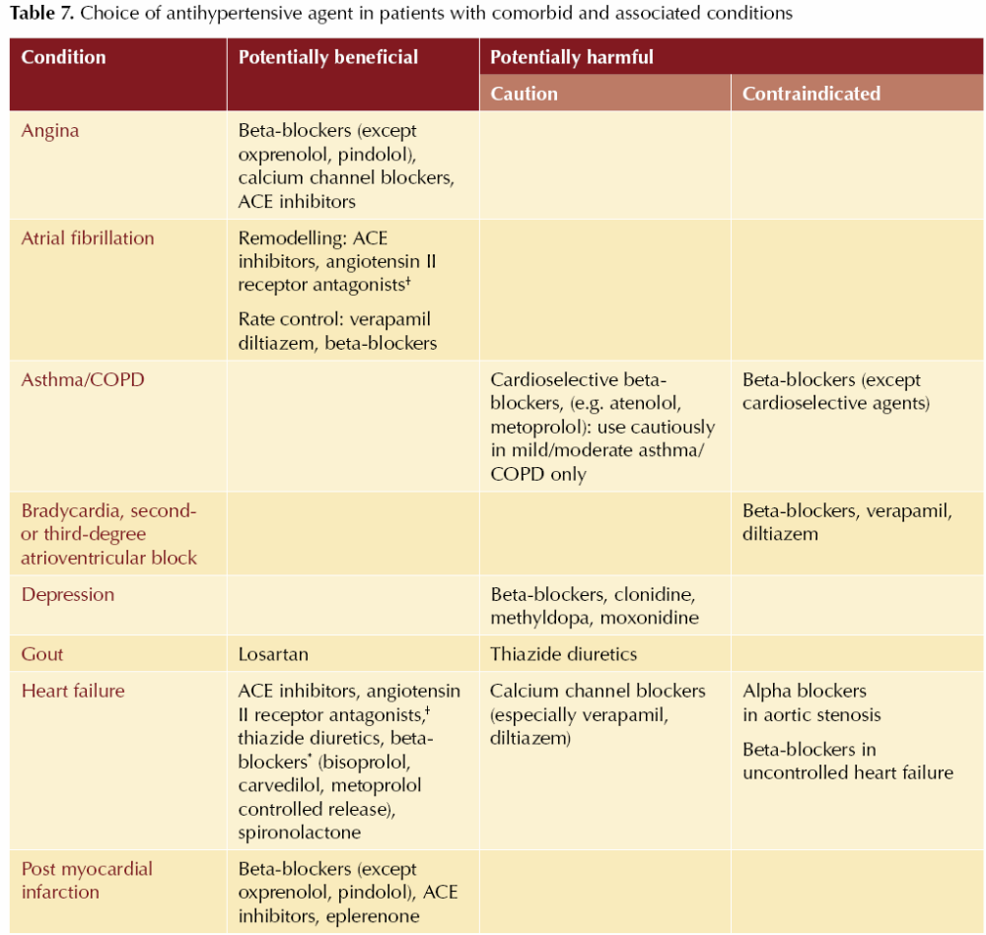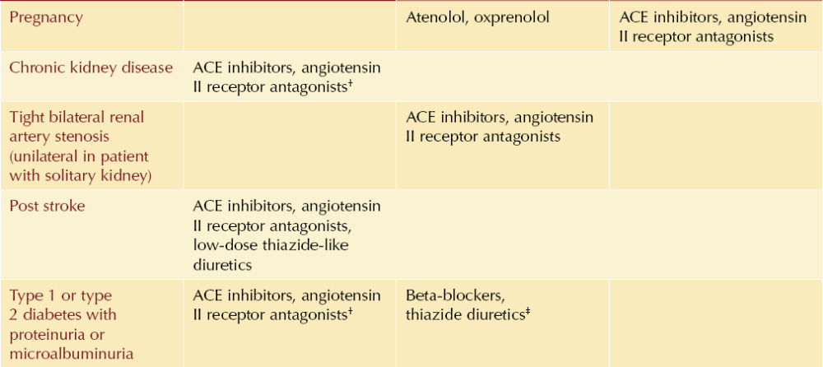

E. Investigations
- Explain the procedure of renal biopsy to a patient, including the potential risks
“A kidney or renal biopsy means removing a small sample from one of your kidneys using a needle. The sample can then be tested under a microscope to find out the cause of your kidney disease. The biopsy will be carried out in either the ward, a special procedure room, the OT or the X-ray department. It takes about thirty minutes and will be done under local anaesthetic. You will usually be asked to lie face down on the bed or couch with a pillow under your stomach. The location of the kidney will be found using an ultrasound machine. The skin on your back over the kidney will be cleaned with antiseptic, and local anaesthetic will be injected into the skin. The biopsy needle will then be passed through the numb area and the kidney sample taken. You will be asked to hold your breath for a few seconds as the kidney moves during breathing. You should usually not be aware of any pain from the biopsy needle but you may feel a little pressure. The doctor may ask to take two or three biopsy samples and occasionally it will not be possible to remove a suitable bit of the kidney.”
Risks
Bleeding is the most serious complication. You will have a blood test before the biopsy to make sure your blood clots normally. You should tell your doctor if you have any problem with easy bleeding or bruising or if you are taking tablets that can affect bleeding such as ASPIRIN, CLOPIDOGREL or WARFARIN.
In about 1 in 10 biopsies there is visible bleeding in the urine that settles by itself.
In less than 1 in 50 biopsies there is more bleeding that requires a blood transfusion.
In less than 1 in 1500 biopsies the bleeding may continue and require an operation to stop the bleeding.
In less than 1 in 3000 biopsies the kidney may have to be removed to stop the bleeding.
Although deaths have occurred following complications of biopsies this is extremely rare.
- Perform and interpret urinalysis
- Use dipstick in freshly voided urine specimen to assess the following;
  - Specific gravity
    - Ratio of the mass of equal volumes of urine/H2O
    - Values <1.01 reflect dilute urine; values >1.02 reflect concentrated urine
  - pH
    - normally between 4.5-7.0; if persistently alkaline consider RTA or UTI with urease-producing bacteria (Proteus)
  - Glucose
    - Freely filtered at glomerulus and reabsorbed in proximal tubule
    - Cause of glycosuria include hyperclycaemia (>9mmol/L) which exceeds tubular reabsorption capacity, increased GFR (eg. in pregnancy) or proximal tubule dysfunction
  - Protein
    - Dipstick detects albumins only
    - Microalbuminuria (30-300mg/day) not detected by dipstick
    - Gold standard is 24 hour urine collection for total protein
  - Leukocyte Esterase
    - Enzyme found in WBC detected by dipstick
    - Presence indicates infection or inflammation
    - 94% specific for diagnosing a UTI
  - Nitrites
    - Nitrates in urine converted to nitrites by bacteria
    - High specificity but low sensitivity for UTIs
  - Ketones
    - +ve in alcoholic/diabetic ketoacidosis, prolonged starvation, fasting
  - Haemaglobin
    - Indicates haemolysis, myoglobinuria (rhabdo) and true haematuria (RBCs seen on microscopy)
- Interpret the results of urine microscopy, urine protein/creatinine ratio and 24 hour urine protein quantification
  - centrifuge urine specimen for 3-5 minutes, discard supernatant, resuspend sediment and plate on slide
  - shaking tube vigorously may disrupt casts
- CELLS
  - Erythrocytes
    - normal range = 2-3 RBCs per high power field (HPF)
    - hematuria = greater than 2-3 RBCs/HPF
    - dysmorphic RBCs and/ or RBC casts suggest glomerular bleeding (e.g. proliferative glomerulonephritis)
    - isomorphic RBCs, no casts suggest extraglomerular bleeding (e.g. bladder Ca)
  - Leukocytes
    - normal range = up to 3 WBCs/HPF
    - pyuria = greater than 3 WBCs/HPF
    - indicates inflammation or infection
    - if persistent sterile pyuria present (i.e. negative culture), consider: chronic urethritis, prostatitis,interstitial nephritis, calculi, papillary necrosis, renal TB, viral infections
  - Eosinophils
    - detected using Wright's or Hansel's stain (not affected by urine pH)
    - consider allergic interstitial nephritis, atheroembolic disease
  - Oval Fat Bodies
    - renal tubular cells filled with lipid droplets
    - seen in heavy proteinuria (e.g. nephrotic syndrome)
- CASTS
  - cylindrical structures formed by intratubular precipitation of Tamm-Horsfall mucoprotein; cells may be trapped within the matrix of protein
- CRYSTALS
  - uric acid- consider acid urine, hyperuricosuria (e.g. gout)
  - calcium phosphate - alkaline urine
  - calcium oxalate - consider hyperoxaluria. ethylene glycol poisoning
  - sulfur - sulfa-containing antibiotics
- Interpret the results of a mid stream urine culture
- >10⁵ CFU in midstream collection suggestive of infection
- If a culture shows growth of several different types of bacteria, then it is likely that the growth is due to contamination
- Discuss the rationale and limitations behind the use of different measures of renal function:
  - plasma creatinine
(b) plasma urea
(c) estimated GFR using MDRD and Cockcroft-Gault formulae
(d) urinary creatinine clearance [toronto notes]
Ways to Estimate GFR
- Calculate creatinine clearance (CrCl)
  - measure plasma [ Cr], 24-hr urine volume and urine [ Cr]
  - GFR= (urine [Cr] xurinevolumeinmL)/(plasma [Cr] xdurationofurine collection in minutes)
  - two major errors limiting the accuracy of CrCl
    - increasing Cr secretion can overestimate true GFR, particularly in azotem.ic patients
    - incomplete urine collection can underestimate true GFR; over-collection of urine overestimates it
- Cockcroft-Gault formula
  - serum Cr used along with age, gender and weight (kg) to estimate GFR (see sidebar)
  - normal range is >90 ml/min (> 1.5 ml/s)
- MDRD (Modification of Diet in Renal Disease) formula
  - most common way in which GFR is estimated
  - complex formula incorporating age, gender, serum Cr, Mrican descent
  - GFR is reported as ml/min/L73m² body surface area
Limitations of Using Serum Cr Measurements
- 1. must be in steady state
  - constant GFR and rate of production of Cr from muscles
  - sudden injury may reduce GFR substantially, but it takes time for Cr to accumulate and then re-establish steady state
- 2. GFR must fall substantially before plasma [ Cr I rises above normal laboratory range
  - with progressive renal failure, remaining nephrons compensate with hyperfiltration
  - GFR is relatively preserved despite significant structural damage
- 3. plasma [ Cr I is influenced by the rate of Cr production
  - lower production with smaller muscle mass (ie. female, elderly, low weight)
- 4. contribution of tubular secretion to Cr excretion is increased when GFR is low
  - CrCl overestimates GFR
  - certain drugs (cimetidine, trimethoprim) interfere with Cr secretion
- 5. errors in Cr measurement
  - very high bilirubin level causes [ Cr] to be falsely low
  - acetoacetate (a ketone body) and certain drugs (cefoxitin) create falsely high [Cr]
Measurement of Urea Concentration
- urea is the major end product of protein metabolism
- plasma urea concentration is a measurement of renal function but should not be use alone as it is modified by a variety of factors
- urea production reflects dietary intake of protein and catabolic rate; increased protein intake or catabolism (sepsis, trauma, GI bleed) causes urea level to rise
- ECF volume depletion causes a rise in urea independent of GFR or plasma [Cr]
- in addition to filtration, a significant amount of urea is reabsorbed along the tubule
- reabsorption is increased in sodium-avid states such as ECF volume depletion
- typical ratio of urea to [Cr] in serum is 1:12
- Discuss the changes seen on renal imaging in obstructive renal disease and chronic kidney disease
- 90% of renal calculi are radio-opaque, so AXR is useful first line investigation in renal imaging for obstruction. Will also show nephrocalcinosis.
- U/S provides information about renal size, renal mass lesions (cysts), and renal pelvic and ureteric dilatation. U/S is 90% sensitive and specific for detecting hydronephrosis.
- Other modalities
  - Plain renal tomogram (renal size and outline)
  - Pyelogram (XR of renal pelvis); retrograde or antegrade to determine location of obstruction
  - Static isotope scan (renal mass lesions, non radio-opaque stones)
  - CT (non radio-opaque calculi, mass lesions, renal artery anatomy)
  - MRI (renal mass lesions, renal arterial flow)
- Describe the potential side effects of gadolinium and intravenous contrast in patients with kidney disease- see F2-3
- Discuss the indications and contraindications of renal biopsy
- Indications for percutaneous needle biopsy include
  - Unexplained acute renal failure or chronic renal insufficiency;
  - Acute nephritic syndromes;
  - Unexplained proteinuria and hematuria;
  - Previously identified and treated lesions to plan future therapy;
  - Systemic diseases associated with kidney dysfunction, such as systemic lupus erythematosus (SLE), Goodpasture's syndrome, and Wegener's granulomatosis, to confirm the extent of renal involvement and to guide management;
  - Suspected transplant rejection, to differentiate it from other causes of acute renal failure; and
  - To guide treatment.
- Relative contraindications include a solitary or ectopic kidney (exception: transplant allografts), horseshoe kidney, uncorrected bleeding disorder, severe uncontrolled hypertension, renal infection, renal neoplasm, hydronephrosis, end-stage renal disease (ESRD), congenital anomalies, multiple cysts, or uncooperative patient.

F. Drugs and therapeutics
- Describe in principle the effects of decreased renal function on drug excretion
  - Glomerular filtration
    - Affects all drugs and metabolites of appropriate molecular size
    - Influenced by protein binding (f=free fraction)
    - Drug filtration rate = GFR x f x [drug]
- Exhibit a working knowledge of the drugs commonly prescribed in the hospital environment that are renally excreted and how dosage adjustments are made in that situation, with particular reference to digoxin, gentamicin, vancomycin and enoxaparin
- Gentamicin
  - Aminoglycosides are almost entirely excreted by the kidney
  - Dosage modifications must be made in renal failure to protect the kidney and inner ear
  - Ability to kill bacteria correlates with peak does whereas nephrotoxicity correlates with steady state concentration: thus the dose should be kept the same and the dosing interval increased (up to every 3 days in dialysis patients)
  - Serum levels of the drug should be checked before the next dose to guide dosing interval
- Digoxin
  - Therapeutic effect correlates with steady state concentration
  - Keep dosing interval the same but decrease the dose
  - Serum levels of the drug should be checked before the next dose to guide dose
- Vancomycin
  - Lower dose and increase dosing interval (1g [15mg/kg vs 30mg/kg in non renal failure) every 5-7 days if on dialysis) to avoid nephrotoxicity and ototoxicity
  - Again serum levels of the drug should be monitored to guide dosages and dosing intervals
- Enoxaparin
  - Patients with end stage renal failure may require monitoring with an anti- factor Xa assay because this condition may prolong the halflife of LMWH
- Discuss the general mechanisms whereby drugs can affect kidney function
- Cite common drugs that are likely to induce acute kidney injury

Drug | Mechanism of Kidney Injury
ACE inhibitors | - Reduction in renal perfusion through alteration of intrarenal hemodynamics.  - Efferent Glomerular arteriolar dilation
NSAIDs | - Inhibition of renal prostaglandins, which help maintain renal vasculature vasodilation and glomerular filtration rate  - Reduction in renal perfusion through alteration of intrarenal hemodynamics  - Afferent Glomerular Arteriolar Constriction
Cyclosporine | - Reduction in renal perfusion through alteration of intrarenal hemodynamics  - Afferent Glomerular Arteriolar Constriction  - Direct tubular toxicity
Tacrolimus | - Reduction in renal perfusion through alteration of intrarenal hemodynamics  - Direct tubular toxicity.
Contrast Agents | - Reduction in renal perfusion through alteration of intrarenal hemodynamics  - Afferent Glomerular Arteriolar Constriction  - Direct tubular toxicity.
Amphotericin B | - Reduction in renal perfusion through alteration of intrarenal hemodynamics  - Direct tubular toxicity
Aminoglycosides | - Direct tubular toxicity
Cisplatin | - Direct tubular toxicity
Methotrexate | - Direct tubular toxicity  - Intratubular obstruction by precipitation of drug (i.e. crystal nephropathy)
Acyclovir | - Intratubular obstruction by precipitation of drug (i.e. crystal nephropathy)  - Acute Tubular Necrosis
Sulfonamides | - Intratubular obstruction by precipitation of drug (i.e. crystal nephropathy)  - Allergic Interstitial Nephritis
Penicillins, cephalosporins, fluoroquinolones | - Allergic Interstitial Nephritis

